ISC2’s Certified in Cybersecurity

**IMPORTANT NOTICE:**

These notes were specifically created for the **ISC2 Certified in Cybersecurity (CC)** exam. While they are designed to help candidates understand key concepts, they should be used alongside the latest **official study materials** and **exam objectives** from ISC2.

The **fundamentals of cybersecurity** remain consistent, but exam structures and topics may evolve over time. Please ensure you verify these notes against the most up-to-date ISC2 resources.

These notes cover foundational security principles, risk management, network security, and other core concepts essential for the ISC2 CC certification. While they may not cover every detail of the exam, they serve as a **helpful supplementary resource**.

I hope these notes assist you on your certification journey! If you find them useful, feel free to share them with others preparing for the ISC2 CC exam.

**Chapter 1: Security Principles**

1.1-Understanding the Security Concepts of information Assurance

CIA is the basic principle behind everything we do in cybersecurity

Fire Inspector Example:

* Check building adheres to safety standards and building has smoke alarms and escape routes (I check to see infrastructure aligns with standards and check everyone knows what to do in case of emergency, then I can act like a paramedic trying to assess and treat any injuries during accident, then sometimes I act like a detective trying to figure out what happened, and sometimes I feel like a fortune teller, trying to predict future so we stay protected from unknown threats

CIA Triad: used to describe security using relevant and meaningful words that make security understandable to management and user and define its purpose

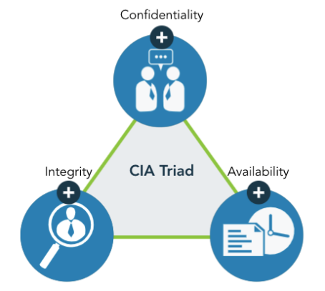

Confidentiality

Confidentiality: relates to permitting authorized access to information, while at the same time protecting information from improper disclosure

* Many system users are guests and can be using compromised machines or applications
* Security professionals need to regulate access and protect the data that needs to be protected
* PII (Personally Identifiable Information): pertains to any data about an individual that could be used to identify them
* PHI (Protected Health Information): information regarding one’s health status
* Classified/Sensitive Information: trade secrets, research, business plans and intellectual property
* Sensitivity: a measure of the importance assigned to information by its owner, or the purpose of denoting its need for protection
  + - Sensitive information: information that if improperly disclosed (confidentiality) or modified (integrity) would harm an organization or individual
    - In many cases, sensitivity is related to the harm to external stakeholders (people or organization that may not be part of the organization that process or use the information)

Integrity

Integrity: the property of information whereby it is recorded, used and maintained in a way that ensures its completeness, accuracy, internal consistency, and usefulness for a stated purpose

* Integrity measures the degree to which something is whole and complete, internally consistent and correct
* Integrity applies to: information or data, systems and processes for business operations, organizations, people and their actions

Data Integrity: the assurance that data has not been altered in unauthorized manner

* This requires the protection of the data in systems and during processing to ensure that it is free from improper modification, errors, or loss of information and is recorded, used and maintained in a way that ensures its completeness.
* Data integrity covers data in storage, during processing and while in-transit
* Information must be accurate, internally consistent and useful for a stated purpose
* The internal consistency of information ensures that information is correct on all related systems so that it is displayed and sorted in the same way on all systems

Consistency, as part of data integrity, requires that all instances of the data be identical in form, content, and meaning

System Integrity: refers to the maintenance of a known good configuration and expected operation function as the system processes the information

* Ensuring integrity begins with an awareness of **state**
* State: the current condition of the system 🡪 the ability to document and understand the state of data or a system at a certain point, creating a baseline
* **Baseline:** refers to the current state of the information, whether it is protected
  + Preserver that state, the information must always continue to be protected through a transaction
  + Going forward from baseline, the integrity of the data or system can always be ascertained by comparing the baseline with the current state
    - If the two DON’T match, then the integrity of the data or system has been compromised
    - Integrity is the primary factor in the reliability of information and systems**

The need to safeguard information and system integrity may be dictated by laws and regulations

* Often it is dictated by the needs of the organization to access and use reliable, accurate information

Availability

**Often targeted during cyberattacks that disrupt services

Availability: can be defined as:

1. Timely and reliable access to information and the ability to use it
2. For authorized users, timely and reliable access to data and information services

* Core concept of availability is that data is accessible to authorized users when and where it is needed and in the form and format required
* This DOESN’T mean that data or systems are available 100% of the time, it means that systems and data meet the requirements of the business for timely and reliable access
* Some systems and data are more critical than others, so security professionals must ensure that the appropriate levels of availability are provided 🡪 requiring consultation to ensure critical systems are identified and available

Availability is often associated with the term **criticality,** b/c it represents the importance an organization gives to data or an information system in performing its operations or achieving its mission

Availability: means that systems and data are accessible at the time users need them

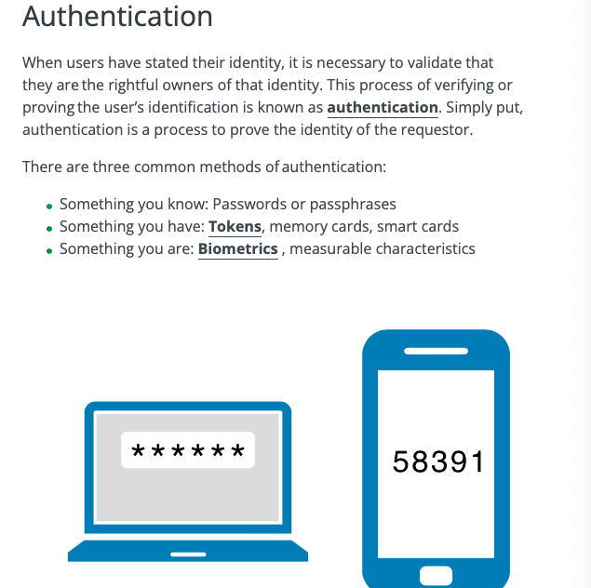

Two Types of Authentication:

1. Single-Factor Authentication(SFA): using only of the common methods of authentication (above)
2. Multi-Factor Authentication (MFA): granting access to users after successfully demonstrating or displaying two or more methods of authentication

Common best practice is to implement at least two of the three authentication techniques:

1. Knowledge-Based Authentication: uses passphrase or secret code to differentiate between authorized and unauthorized user
   * Con: vulnerable to variety of attacks (Ex help desk may receive call to reset a user’s password but for threat actor 🡪 hard to decipher)
   * Ex) Personal Identification Number (PIN), password

Using a combination of user ID and password consists of two things you know, but does not meet requirement of two or more different authentication methods, so not as secure

* + - SFA

Non-Repudiation: the protection against an individual falsely denying performed a particaly action in legal terminology

* Ensures that people are held responsible for transactions they conducted
* “Essentially, data that cannot be denied”

Privacy

Privacy: the right of an individual to control the distribution of information about themselves

* Security and privacy both focus on the protection of personal and sensitive data, but there are differences between them

GDPR (General Data Protection Regulation): gives any one within border of EU control over what personal information companies can compile and retain about them

* any entity anywhere in the world handling private data of people in a particular legal jurisdiction must abide by it privacy requirements
* applies to all organizations (foreign or domestic) doing business in the EU or any persons in the EU
* Companies operating or doing business within the United States may also fall under several state legislation that regulate the collection and use of consumer data and privacy
* Members nations of the EU enact laws to put GDPR into practice and sometimes add more stringent requirements

US

* HIPAA ( Health Insurance Portability Acountabiliyt Act): controls how the privacy of medical infomdration must be maintianed

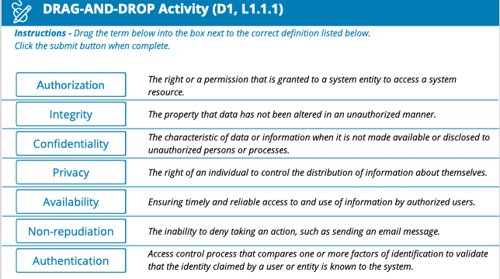

PII

* Sometimes disclosing information on its own is not problematic, but when it is combine with other pieces of data, it can be used to infer the identify of individual, making it PII
* Ex) Birthdate

1.2-Understand the Risk Management Process

Far too often, businesses fail to proactively manage risk

* Assessing and analyzing risk should be a continuous and comprehensive exercise in any organization
* As a member of an organization’s security team, you work through:
  + Risk assessment
  + Analysis of Mitigation
  + Remediation
  + Communication

There are many risk management frameworks and models available

* Each organization determines what constitutes risk and the level of risk it is willing to accept

Risk: measure of the extend to which an entity is threated by a potential circumstance or event

1. The adverse impacts that would arise if the circumstance or even occurs
2. Likelihood of Occurrence

Information Security Risk: reflects the potential adverse impacts that result from the possibility of unauthorized access, use, disclosure, disruption, modification, or destruction of information and/or information systems

* Indicates that risk is associated with threats, impacts, likelihood, and it also indicates that IT risk is a subset of business risk

Risk Management

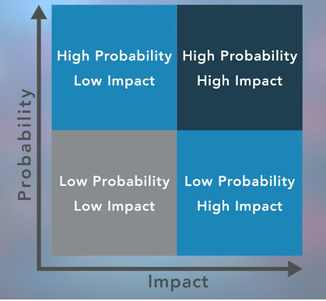

Asset: something in need of protection

Risks can come from malware, social engineering, DDoS, or other situations (fire, violent crime, natural disasters)

Vulnerability: a gap or weakness in an organization’s protection of its valuable assets, including information

Threat: something or someone that aims to exploit a vulnerability to gain unauthorized access to further/achieve its goals/objectives

Exploiting a vulnerability, the threat can harm an asset

IT environment where production takes place = asset

Our responsibility: to determine likelihood of risk being exploited and implementing mitigation efforts

Threat Actor Examples:

* Insiders (intentional or accident)
* Outside individuals or informal groups
* Entities that are non-political (competitors, cybercriminals)
* Political groups (terrorists, nation-states, hacktivists)
* Intelligence/information gathers
* Technology (botnets, AI)

**\*\*Threat Actor: the means by which a threat actor carries out their objectives**

Vulnerability: “put yourself in the adversaries shoes to get a better perspective on how they can potentially exploit possible vulnerabilities

When Determining Organization’s Vulnerability:

1. Probability: of a potential vulnerability being exploited

* Likelihood of Occurrence: based on subjective analysis of the probability that a given threat or set of threats is capable of exploiting a given vulnerability or set of vulnerabilities

1. Impact: the magnitude of harm that can be expected to result from the consequences of unauthorized disclosure of information, unauthorized modification of information, unauthorized destruction of information, or loss of information or information system availability

Risk Identification

* Not a one and done activity, it’s a recurring process of identifying different possible risks, characterizing them, and them, and then estimating their potential for disrupting the organization
* Identify risk to communicate it clearly
* **Employees at all levels of the organization are responsible for identifying risk**
* **Identify risk to protect against it**

As a security professional, you are likely to assist in:

* Risk assessment at a system level
* Focusing on process, control, monitoring or incident response
* Recovery activities

Risk Assessment

Risk Assessment: the process of identifying, estimating, and prioritizing risks to an organization’s operations (including its mission, functions, image and reputation), assets, individuals, other organizations and even the nation

* Should result in aligning (or associating) each identified risk resulting from the operation of an information system with the goals, objectives, assets or processes that the organization uses, which in turn aligns with or directly supports achieving the organization’s goals and objectives

Common Risk Assessment Activity

* Identifies the risk of fire to a building
* While there are many ways to mitigate risk, the primary goal of a risk assessment is to estimate and prioritize

Risk Assessment Results are often documented as a report or presentation given to mangament for their use in prioritizing the identified risk(s)

* This report is provided to management for review and approval
  + - Sometimes indicates need for more in-depth risk assessment performed by internal or external resources

Risk Treatment

Risk Treatment: relates to making decisions about the best actions to take regarding the identified and prioritized risk

* The decisions made are dependent on the attitude of management toward risk and the availabinlity and cost of risk mitigation

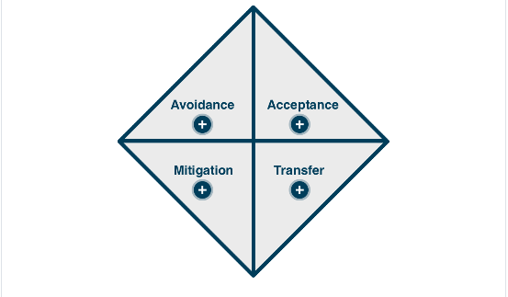

Risk Avoidance: the decision to attempt to eliminate the risk entirely

* Includes ceasing operations for some or all of the activities of the organization that are exposed to a particular risk
* Organization leadership may choose risk avoidance when the potential impact of a given risk is too high or if the likelihood of the risk being realized is simply too great

Risk Acceptance: taking no action to reduce the likelihood of a risk occurring

* Management may opt for conducting the business function that is associated with the risk without any further action on the part of the organization, either b/c the impact or likelihood of occurrence is negligible, or b/c the benefit is more than enout to offset that risk

Risk Mitigation: the most common type of risk management and includes taking actions to prevent or reduce the possibility of a risk event or its impact

* Mitigation can involve remediation measures, or controls such as security controls, establishing policies, procedures, and standards to minimize adverse risks
* Risk cannot always be mitigated, but mitigation such as safety measures should always be in place

Risk Transfer: the practice of passing the risk to another party, who will accept the financial impact of the harm resulting from a risk being realized in exchange for payment

* Typically this is insurance policy

Risk Management Process

Asset: something that we need to protect (data or physical)

Vulnerability: weakness in the system

* Due to lack of knowledge or out-dated software (awareness training)

Threat: something or someone that could cause harm once they learn that we have a weakness

At beginning of risk management process, organizations need to decide how much risk they are willing to take, called **appetite/risk tolerance**

Ex) if there is a big game, you have a low risk tolerance for power outage

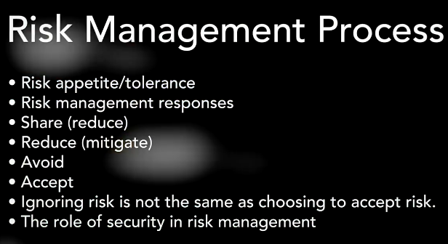

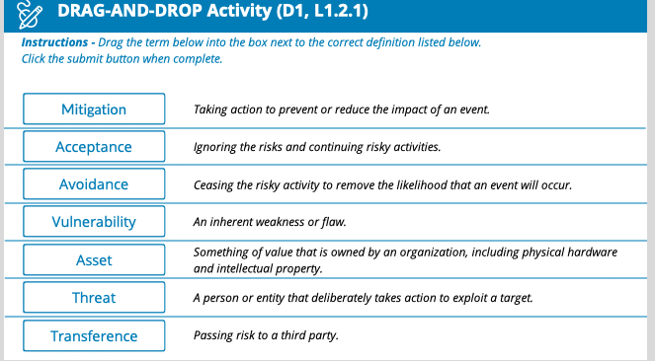

When Dealing with Risk Determine:

1. Avoid
2. Accept
3. Mitigate
4. Transfer

Quantitative Risk Assessment: self-explanatory

Qualitative Risk Assessment: allows us to rank or estimate the probability of a particular risk occurring and the loss or impact of that risk using terms such as high, low, moderate, and severe

If you identify a risk, you can mitigate it via layers of security, such as MFA

Risk Priorities

When risks have been identified, it is time to prioritize and analyze core risks through qualitative risk analysts and/or quantitative risk analysis

* Necessary to determine root case and narrow down apparent risks and core risks
* Understanding the company’s overall mission is important
* Risk matrix used

Risk Matrix:

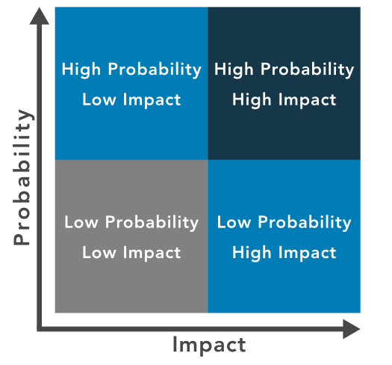

* Helps identify priority as the intersection of likelihood of occurrence and impact
* Low likelihood and low impact = low priority
* High likelihood and high impact = high priority

When business make decisions based on risk priorities, they need to consider: risk likelihood, risk impact, and risk tolerance

Security Professionals aim to maintain the levels of risk within management’s limit of risk tolerance

* Risk tolerance is also impacted by geography (tsunami, volcanoes, blizzard, power outage etc.)
* If company has low risk tolerance for downtime, they will spend more on generators and fuel sources to provide a higher level of assurance

**\*\*Risk Tolerance Drives Decision Making**

1.3- Understand Security Controls

Safe Guards = controls that secure physical locations and networks

Security Controls

* Security controls pertain to the physical, technical and administrative mechanisms that act as safeguards or countermeasures prescribed for an information system to protect the CIA of the system and its information

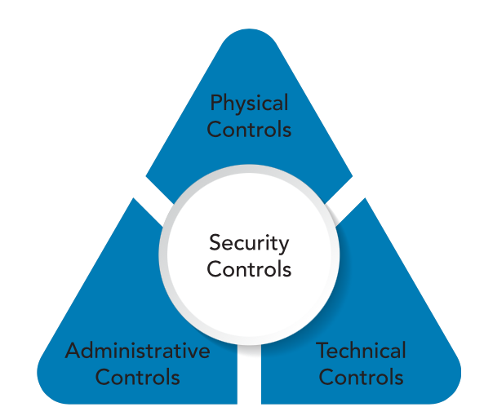

Physical Controls

* Physical controls address process-based security needs using physical hardware devices, such as badge readers, architectural features of building and facilities, and specific security actions to be taken by people
* They typically provide ways of controlling, directing or preventing the movement of people and equipment throughout a specific physical location, such as an office suite, factory or other facility
* Physical controls also provide protection and control over entry onto the land surrounding the buildings, parking lots or other areas that are within the organization’s control
* In most cases physical controls are supported by technical controls as a means of incorporating them into an overall security system
* Visitors and guests-accessing a workplace, for example, must often enter the facility through a designated entrance and exit, where they can be identified, their visit’s purpose assessed, and then allowed or denied entry
* Employees would enter, perhaps through other entrances, using company-issued badges or other tokens to assert their identity and gain access
* These require technical controls to integrate the badge or token readers, the door release mechanisms and the identity management and access control systems into a more seamless security system

Technical Controls/Logical Controls

* Technical/logical controls are security controls that computer systems and networks directly implement
* These controls can provide automated protection from unauthorized access or misuse, facilitate detection of security violations and support security requirements for applications and data
* Technical controls can be configuration settings or parameters stored as data, managed through a software GUI, or they can be hardware settings done with switches, jumper plugs or other means
* The implementation of technical controls always requires significant operational considerations and should be consistent with the management of security within the organization

Administrative Controls/Managerial Controls

* Administrative/Managerial Controls are directives, guidelines or advisories aimed at the people within the orgnaizaiton
* They provide frameworks, constraints and standards for human behavior, and should cover the entire scope of the organization’s activities and its interactions with external parties and stakeholders
* It is vitally important to realize that administrative controls can and should be powerful, effective tools for achieving information security
* Even the simplest security awareness policies can be an effective control, if you can help the organization fully implement them through systematic training and practice
* Many organizations are improving their overall security posture by integrating their administrative controls into the task-level activities and operation decision processes that their workforce uses throughout the day
* This can be done by providing them as in-context ready reference and advisory resources, or by linking them directly into training activites

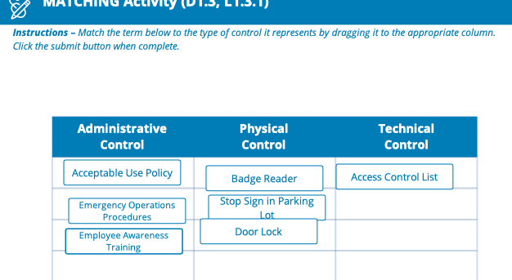

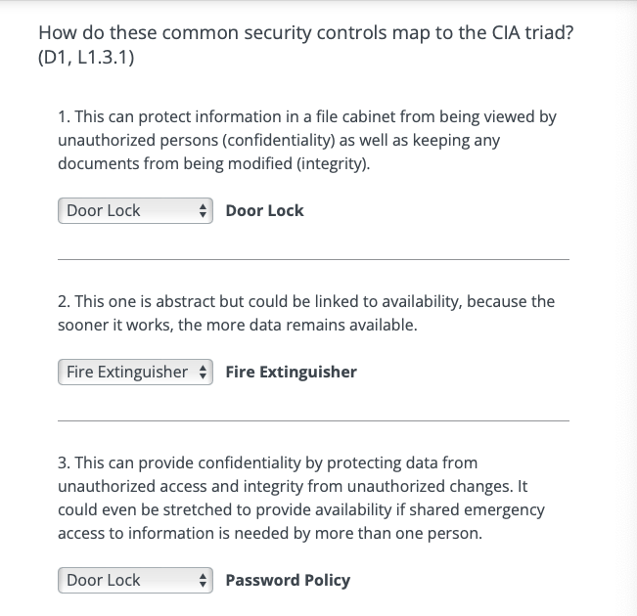

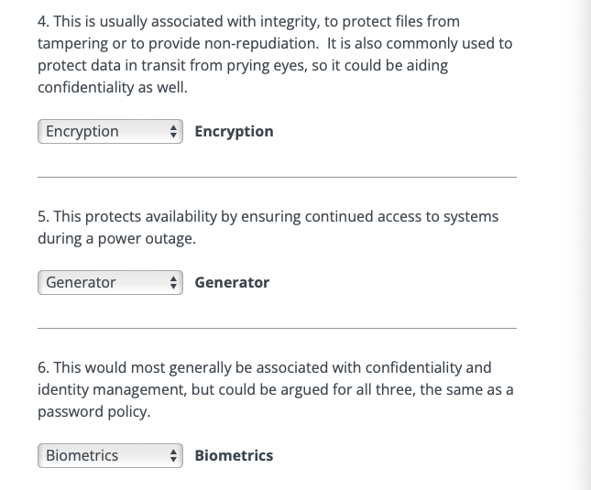

What Activities can Threaten Elements of CIA TRIAD

* Sharing passwords
* Unattended laptops
* Downloading corrupted malicious files onto workstation

1.4- Understanding Governance Elements and Processes

Every business and organization exists to fulfill a purpose and policies and procedures are in place to guide the organization in its pursuit of achieving its goals and missions

* They are guided by laws and regulations created by governments to enact public policy
* Laws and regulations guide the development of standards, which cultivate policies, which result in procedures

Procedures: the detailed steps to complete a task that support departmental or organizational policies

Policies: put in place by organizational governance, such as executive management, to provide guidance in all activities to ensure that the organization supports industry standards and regulations

Standards: used by governance teams to provide a framework to introduce policies and procedures in support of regulations

Regulations: commonly issued in the form of laws, usually from government (not be confused with governance) and typically carry financial penalties for non-compliance

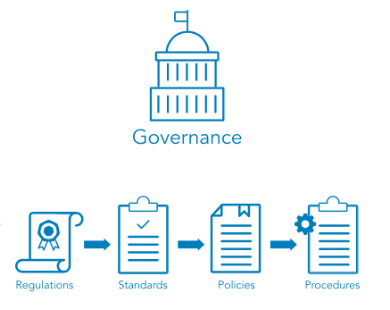

Regulations and Laws

* Regulations and associated fines and penalties can be imposed by governments at the national, regional or local level
* Laws can be imposed and enforced differently in different parts of the world

HIPAA (Health Insurance Portability and Accountability Act) 🡪 1996

* Example of a law that governs the use of protected health information (PHI) in the United States
* Violations of the HIPAA rule carries the possibility of fines and/or imprisonment for both individuals and companies

GDPR (General Data Protection Regulation)

* Enacted by the European Union (EU) to control use of PII (Personally Identifiable Information) of its citizens and those in the EU
* It includes provisions that apply financial penalties to companies who handle data of EU citizens and those living in the EU even if the company does not have a physical presence in the EU, giving this regulation an international reach

Multinational Organizations are subject to regulations in more than one nation in addition to multiple regions and municipalities

* Organizations need to consider the regulations that apply to their business at all levels –national, regional, local—and ensure that they are compliant with the most restrictive regulation

Standards

* Organizations use multiple standards as part of their information systems security programs, both as compliance documents and as advisories or guidelines
* Standards cover a broad range of issues and ideas and may provide assurance that an organization is operating with policies and procedures that support regulations and are widely accepted best practices

ISO (International Organization for Standardisation)

* Develops and publishes international standards on a variety of technical subjects, including information systems and information security, as well as encryption standards
* ISO solicits input from the international community of experts to provide input on its standards prior to publishing
* Documenting outlining ISO standards may be purchased online
* One of its standards it publishes is how to destroy data in secure fashion

NIST (National Institute of Standards and Technology)

* A United States government agency under the Department of Commerce and publishes a variety of technical standards in addition to information technology and information security standards
* Many of the standards issued by NIST are requirements for US government agencies and are considered recommended standards by industries worldwide
* NIST standards solicit and integrate input from industry and are free to download from the NIST website

IETF (Internet Engineering Task Force)

* There are standards in communication protocols that ensure all computers can connect with each other across borders, even when the operators do not speak the same language

IEEE (Institute of Electrical and Electronics Engineers)

* Sets standards for telecommunications, computer engineering and similar disciplines

Policies

* Policy is informed by applicable law(s) and specifies which standards and guidelines the organization will follow
* Policy is broad, but not detailed; it establishes context and sets out strategic direction and priorites
* Governance policies are used to moderate and control decision-making, to ensure compliance when necessary and to guide the create and implementation of other policies
* Policies are often written at many levels across the organization
* High-level governance policies are used by senior executives to shape and control deciions-making processes
* Other high-level policies direct the behavior and activity of the entire organization as it moves toward specific or general goals and objectives
* Functional areas such as human resource management, finance and accounting, and security and asset protection usually have their own sets of policies
* Whether imposed by laws and regulations or by contracts, the need for compliance might also require the development of specific high-level policies that are documented and assessed for their effective use by the organization
* Policies are implemented, or carried out, by people
* Someone must expand the policies from statements of intent and direction into step-by-step instructions, or procedures

Procedures

* Procedures define the explicit, repeatable activities necessary to accomplish a specific tasks or set of tasks
* They provide supporting data, decision criteria or other explicit knowledge needed to perform each task
* Procedures can address tone-time or infrequent actions or common, regular occurrences
* Procedures establish the measurement criteria and methods to use to determine whether a task has been successfully completed
* Properly documenting procedures and training personnel on how to locate and follow them is necessary for deriving the maximum organizational benefits from procedures

Importance of Governance Elements

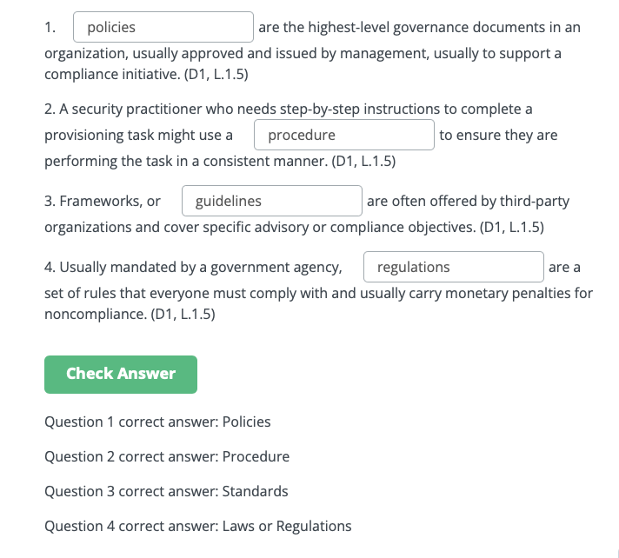

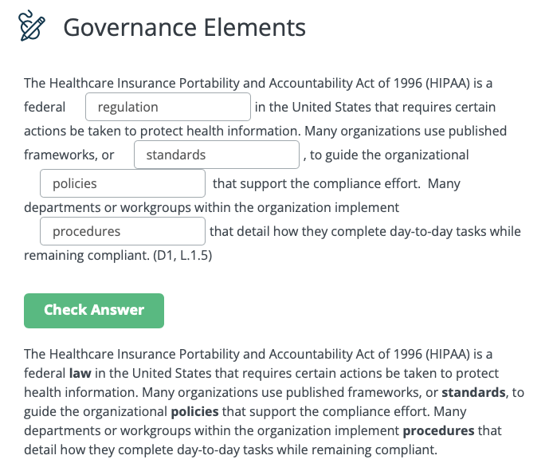

1.5- Understanding ISC2 Code of Ethics

Professional Code of Conduct

All information security professionals who are certified by ISC2 recognize that certification is a privilege that must be both earned and maintained

Every ISC2 member is required to commit to fully support the ISC2 Code of Ethics

ISC2 Code of Ethics Preamble

* States the purpose and intent of the ISC2 Code of Ethics
* The safety and welfare of society and the common good, duty to our principals, and to each other, requires that we adhere, to the highest ethical standards of behavior
* Therefore, strict adherence to this Code is a condition of certification

ISC2 Code of Ethics Canons

* The Canons represent the important beliefs held in common by the members of ISC2
* Cybersecurity professionals who are members of ISC2 have a duty to the following four entities in the Canons:

1. Protect society, the common good, necessary public trust and confidence, and the infrastructure
2. Act honorable, honestly, justly, responsibly, and legally
3. Provide diligent and competent service to principals
4. Advance and protect the professions

Iris Scan:

* Match blood vessels in individual’s retina
* Tells difference between male and female
* Tells if female pregnant

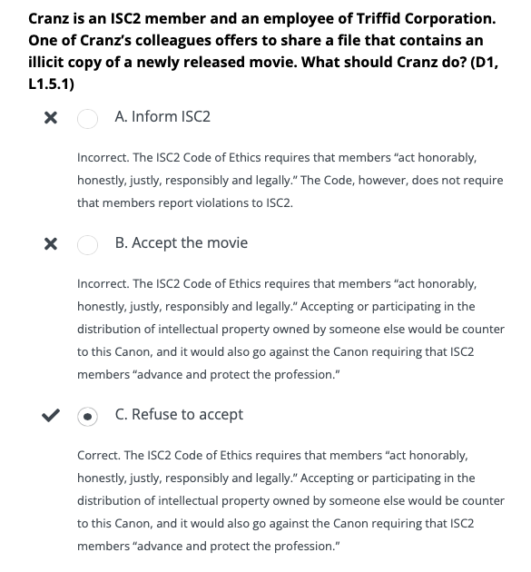

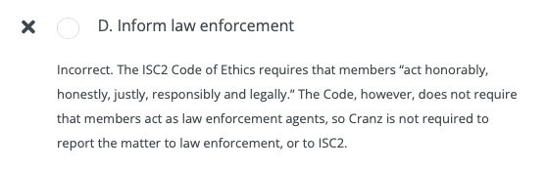

Chapter 1 Terms

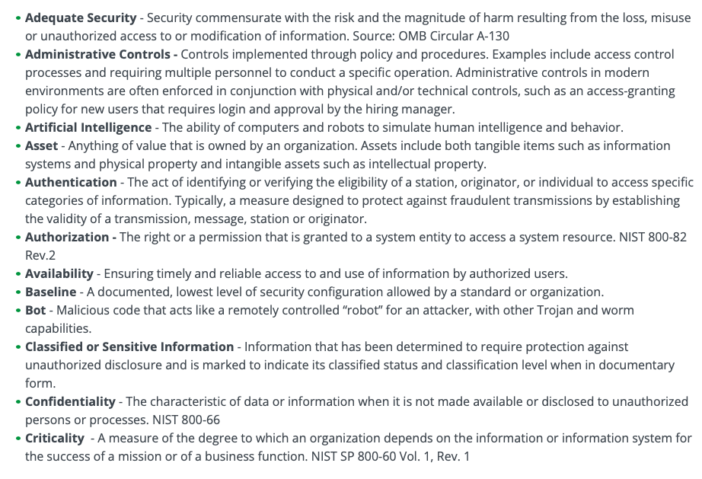

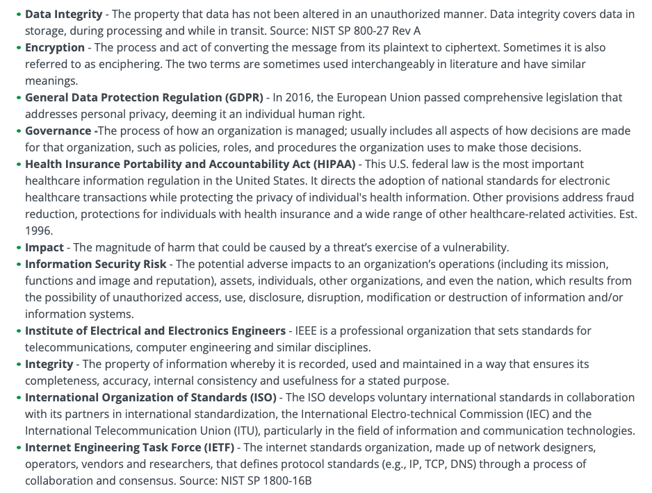

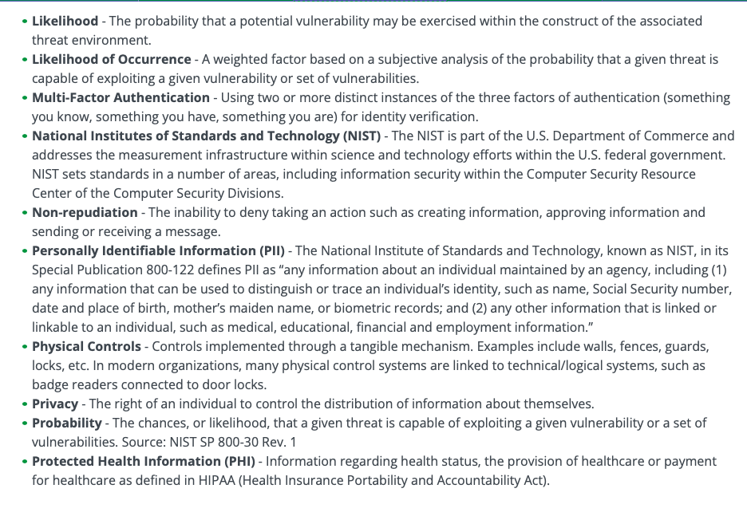

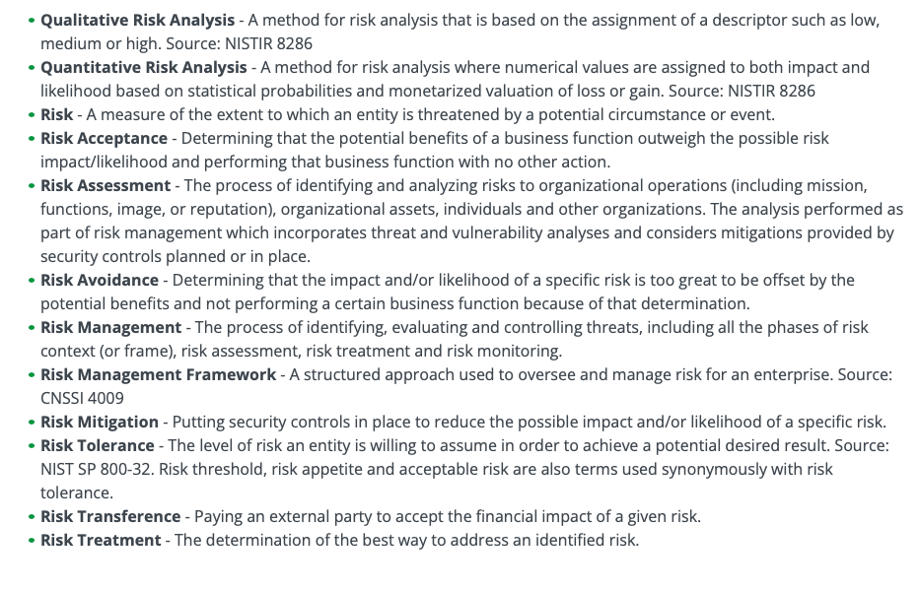

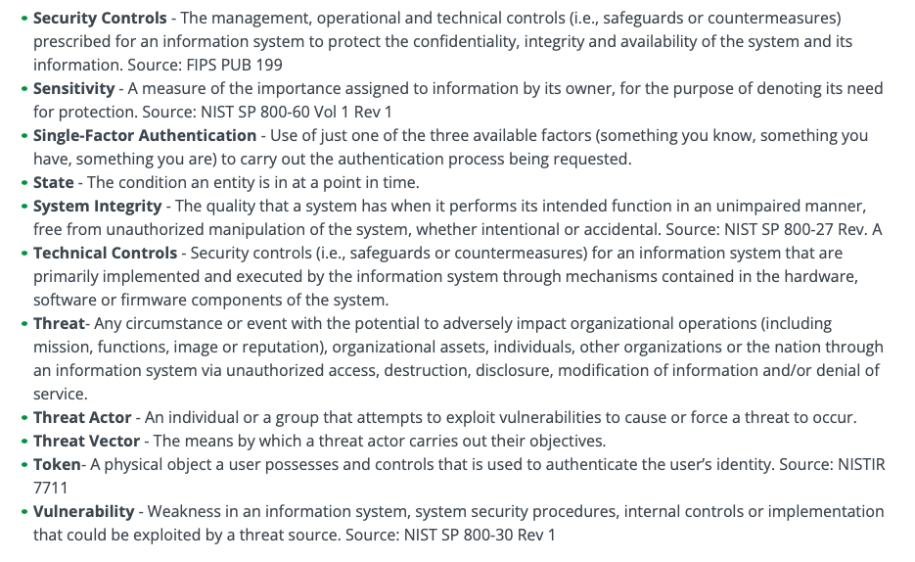

**END OF CHAPTER 1**

**Chapter 2: Incident Response, Business Continuity and Disaster Recovery Concepts**

2.1-Understanding Incident Response

Security professionals also play the role of first responders b/c despite striving to protect systems from malicious actors and prevent human carelessness, things go wrong

Breach: the loss of control, compromise, unauthorized disclosure, unauthorized acquisition, or any similar occurrence where: a person other than an authorized user accesses or potentially accesses PII; or an authorized user access PII for other than an authorized purpose

Event: any observable occurrence in a network or system

Exploit: a particular attack that exploits system vulnerabilities

Incident: an event that actually or potentially jeopardises the CIA of an information system or the information the system processes, stores or transmits

Intrusion: a security event, or combination of events, that constitutes a deliberate security incident in which an intruder gains, or attempts to gain, access to a system or system resource without authorization

Threat: any circumstance or event with the potential to adversely impact organizational operations (including mission, functions, image or reputation), organizational assets, individuals, other organizations or the nation through an information system via unauthorized access, destruction, disclosure, modification of information and/or denial of service

Vulnerability: weakness in an information system, system security procedures, internal controls or implementation that could be exploited by a threat source

Zero Day: a previously unknown system vulnerability with the potential of exploitation without risk of detection or prevention b/c it does not, in general, fit recognized patterns, signatures, or methods

Goal of Incident Response

* It is inevitable that adverse events will happen that have the potential to affect the business mission or objectives, every organization MUST be prepared
* The priority of any incident response is to protect life, health, and safety
  + Safety is ALWAYS chosen first

Incident/Crisis Management Goal: primary goal it to be prepared

* Preparation requires policy and a response plan to lead an organization through crisis

If an event has the potential to disrupt the business’s mission, then it is called an incident

* **Every organization must have an incident response plan that will help preserve business viability and survival

The incident response process is aimed at reducing the impact of an incident so the organization can resume the interrupted operations ASAP

Components of Incident Response Plan

The incident response policy should reference an incident response plan that all employees will follow, depending on their role in the process

* The organization’s vision, strategy, and mission should shape the incident response process
* Procedures to implement the plan should define the technical processes, techniques, checklists and other tools that teams will use when responding to an incident

Common Incident Response Plan Components

Preparation

* Develop a policy approved by management
* Identify critical data and systems, single points of failure
* Train staff on incident response
* Implement an incident response team
* Practice incident identification (FIRST RESPONSE)
* Identify roles and responsibilities
* Plan the coordination of communication between stakeholders
  + Consider the possibility that a primary method of communication may not be available

Detection and Analysis

* Monitor all possible attack vectors
* Analyze incident using known data and threat intelligence:
* Prioritize incident response
* Standardize incident documentation

Containment, Eradication and Recovery

* Gather evidence
* Choose an appropriate containment strategy
* Identify the attacker
* Isolate the attack

Post-Incident Activity

* Identify evidence that may need to be retained
* Document lessons learned

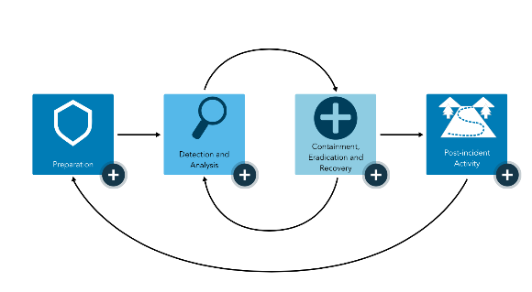

Consulting with Management

Standardized incident response put in place to maintain consistency, otherwise everybody has different ways of communicating and responding to situations

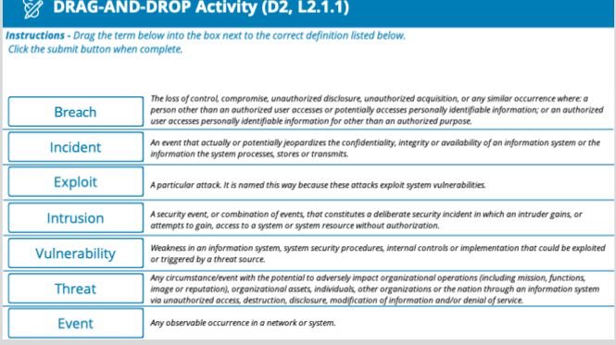

2.2- Understanding Business Continuity (BC)

Importance of Business Continuity

* The intent of a business continuity plan is to sustain business operations while recovering from a significant disruption
* A key part of the plan is communication, including multiple contact methodologies and backup numbers in case of a disruption of power or communications
* Many organization will establish a phone tree, so that if one person is not available, they know who else to call
* Organizations will go through their procedures and checklists to make sure they know exactly who is responsible for which action
* No matter how many times they have flown, without fail, pilots go through a checklist before take-off
* Similarly, there must be established procedures and a thorough checklist, so that no vital element of business continuity will be missed
* **The numbers of specific organizations can bypass the normal cell phone services and use military-grade networks in case of major cybersecurity disruptions that knock out their communications (ex. Hospitals)

Business Continuity: refers to enabling the critical aspects of an organization to function, perhaps at a reduced capacity, during a disruption caused by any form of disturbance, attack, infrastructure failure or natural disaster

* Most incidents are minor and can be handled easily with minimal impact
* A system may require a reboot, but after a few minutes it’s back in operation and the incident is over

Once in a while a business may be victims to a major incident and the organization cant just follow an incident plan, but must move toward business continuity

Business Continuity: includes planning, preparation, response and recovery operations, but it does not generally include activities to support full restoration of all business activities and services

* It focuses on the critical products and services that the organization provides and ensures those important areas can continue to operate even at a reduced level of performance until business returns to normal

Developing a business continuity plan requires a significant organizational commitment in terms of both personnel and financial resources

* To gain this commitment, organizational support for business continuity planning efforts must be provided by executive management or an executive sponsor
* Without the proper support, business continuity planning efforts have little chance of success

Components of a Business Continuity Plan (BCP)

Business Continuity Planning: the proactive development of procedures to restore business operations after a disaster or other significant disruption to the organization

* Members from across the organization should participate in createing the BCP to ensure all systems, processes and operations are accounted for in the plan

In order to safeguard the CIA of information, the technology must aling with business needs

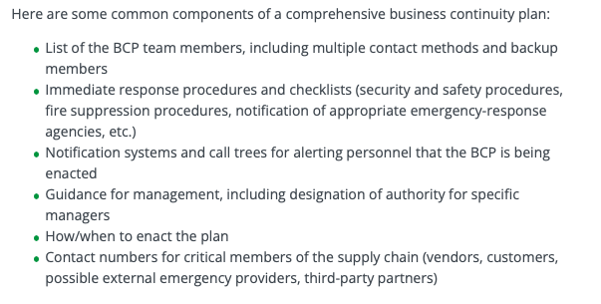

Red book: given to appropariate individual outside of facilty

* All procedure outlined in this document
* In case access to electricity, not possible
* Important to update red book EVERY TIME electronic version is updated

An important component of the business continuity plan details how and when the plan is enacted

Business Continuity Plan should be tested routinely (determined by organization) and when changes happen in business environment

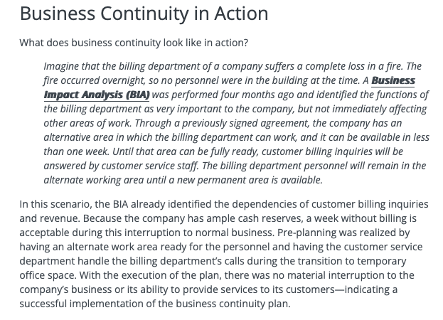

2.3- Understand Disaster Recovery (DR)

Disaster Recovery: steps in where BC leaves off

* When a disaster strikes or an interruption of business activities occurs, the Disaster Recovery Plan (DRP) guides the actions of emergency response personnel until the end goal is reached – which is to see the business restored to full last-known reliable operations

Disaster Recovery refers specifically to restoring the information technology and communications services and systems needed by an organization, both during the period of disruption caused by any event and during restoration of normal services

* The recovery of a business function may be done independently of the recovery of IT and communications services; however, the recovery of IT is often crucial to the recovery and sustainment of business operations
* Whereas, business continuity planning is about maintaining critical business functions, disaster recovery planning is about restoring IT and communications back to full operations after a disruption

We need to make sure that an organization’s critical systems are formally identified and have backups that are regularly tested

* Sometimes an incident is not recognized or detected until days or months later

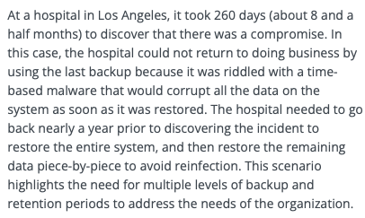

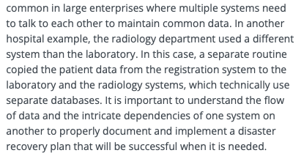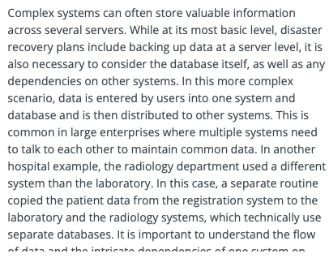

Components of a Disaster Recovery Plan

* Depending on the size of the organization and the number of people involved in the DRP effort, organizations often maintain multiple types of plan documents, intended for different audiences:

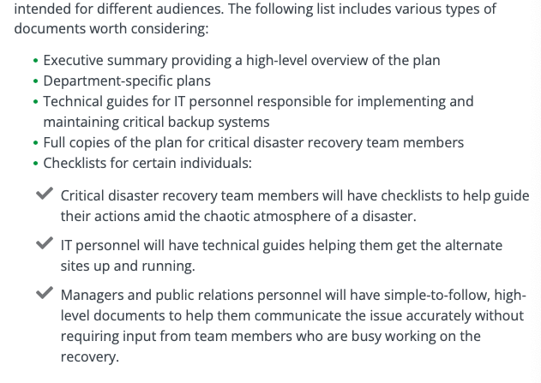

An example of disaster recovery in action is the use of system backups

Chapter 2 Terminology

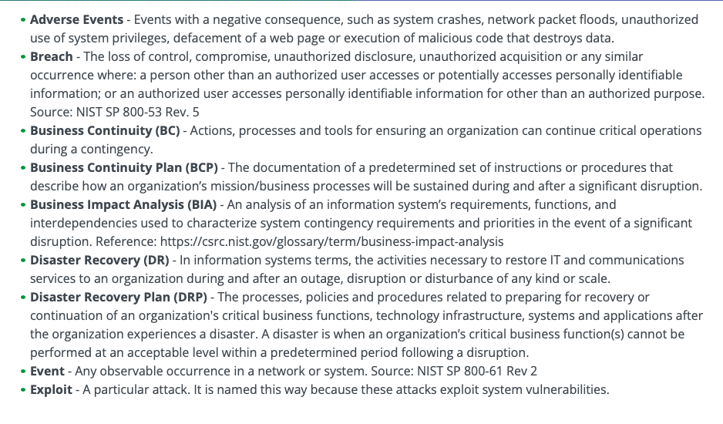

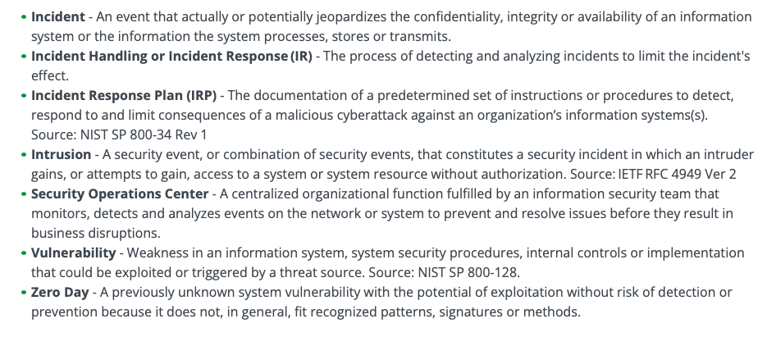

**END OF CHAPTER 2**

**Chapter 3: Access Control Concepts**

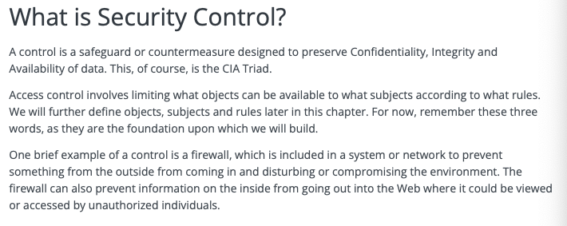

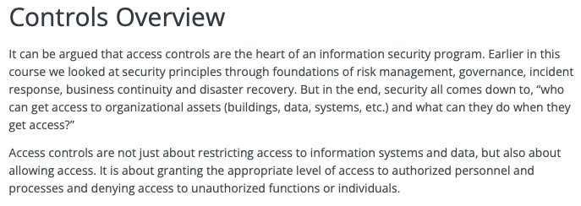

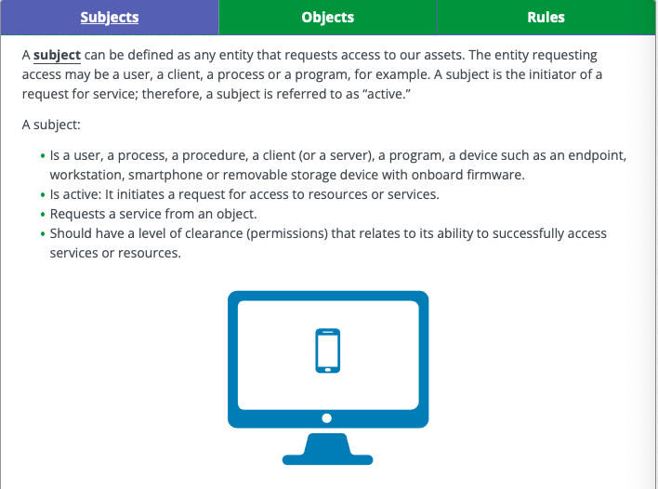

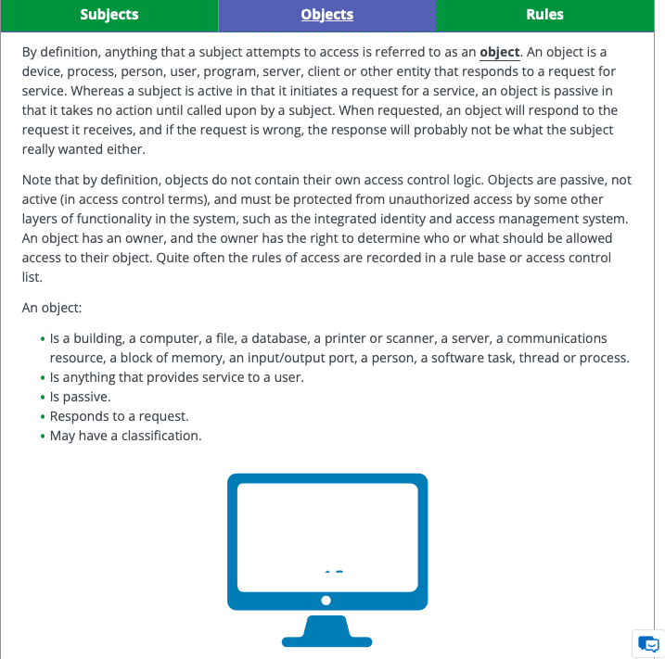

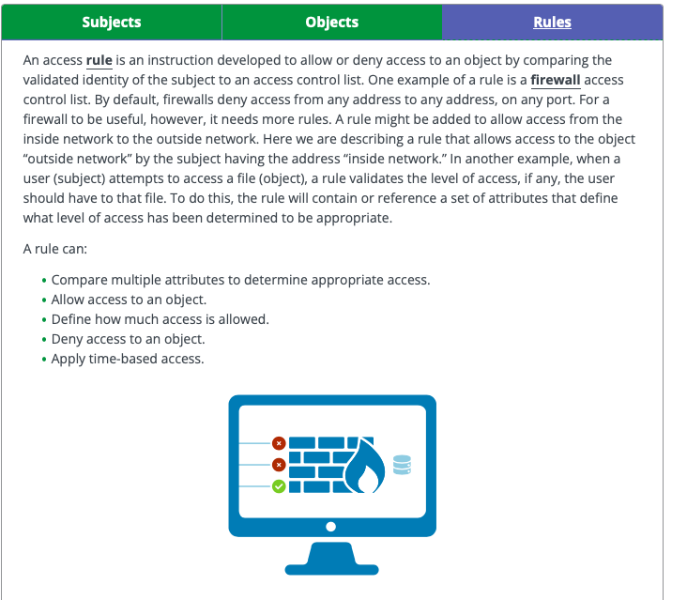

Controls and Risks

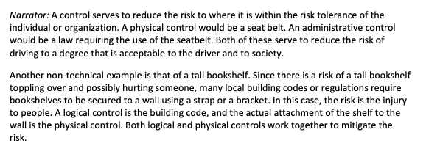

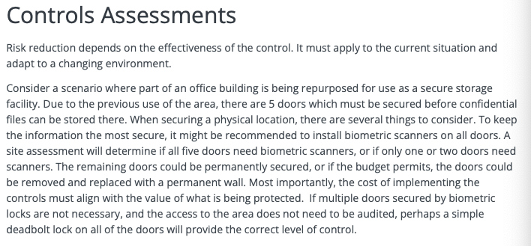

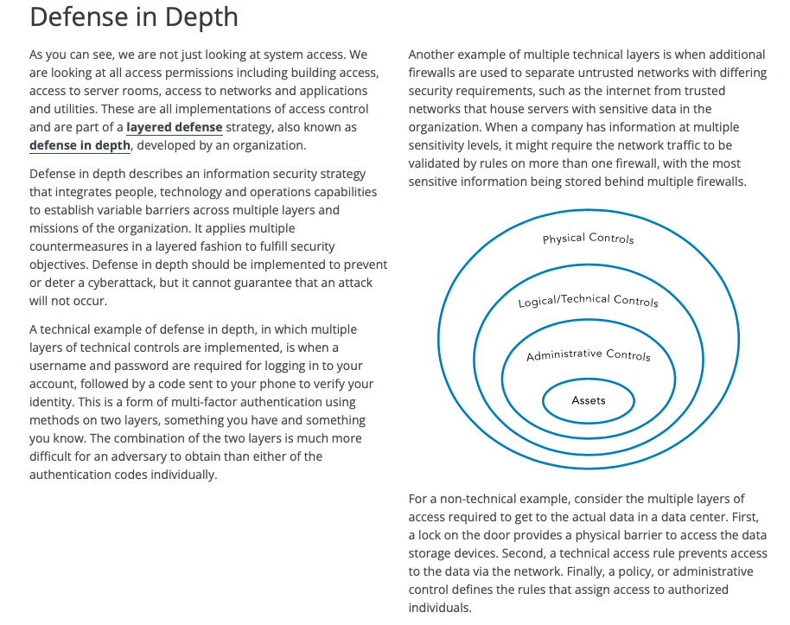

Defense in Depth Practice

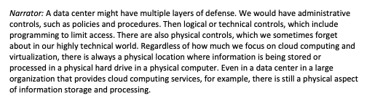

Principle of Least Privilege

Principle of Least Privilege: a standard permitting only minimum access necessary for users or programs to fulfill their function

* Users are provided access only to the systems and programs they need to perform their specific jobs or tasks

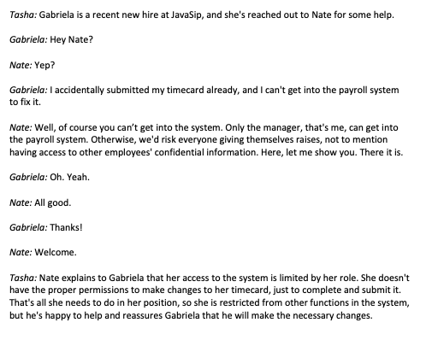

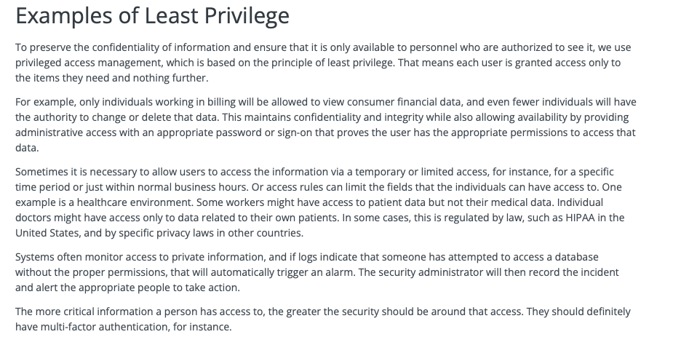

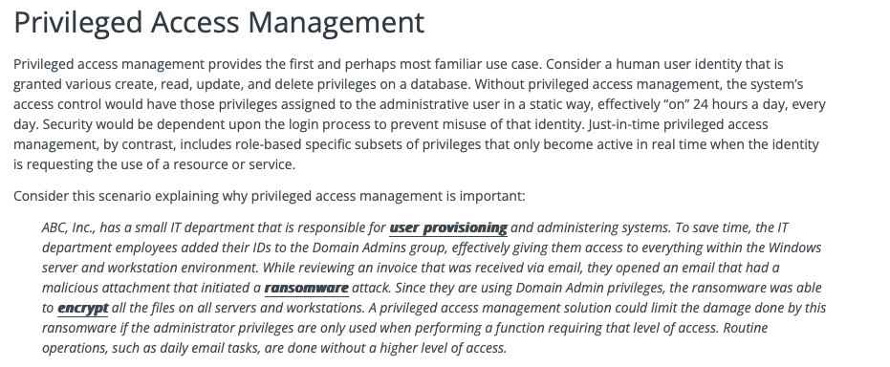

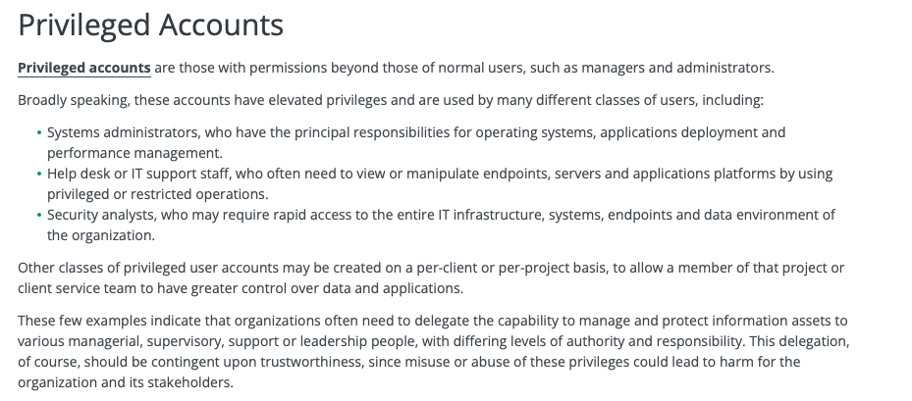

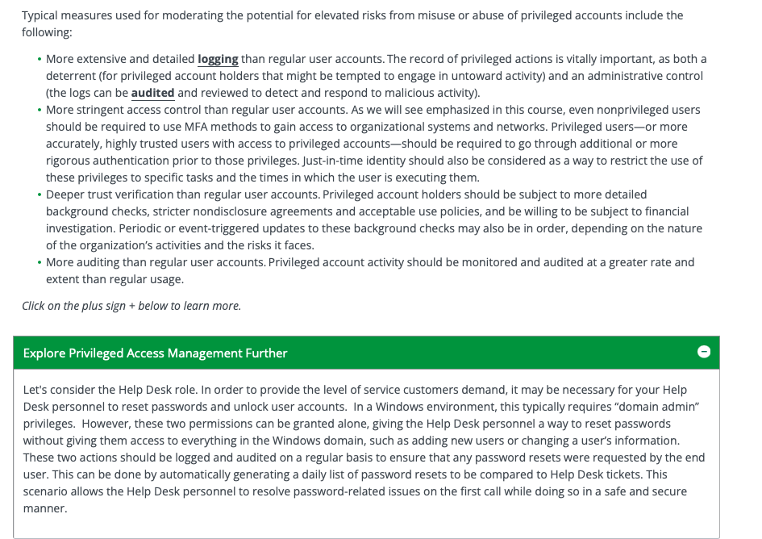

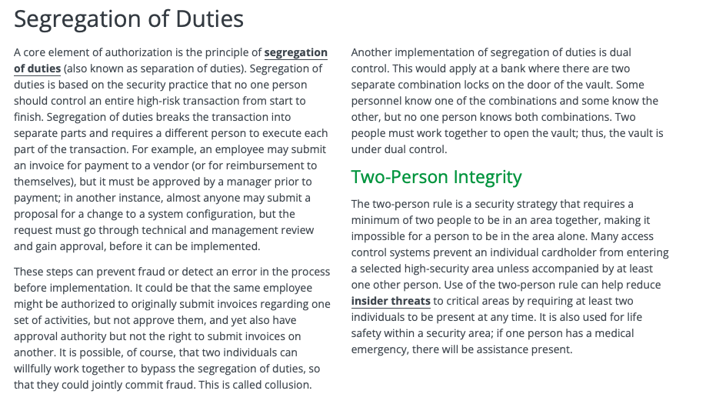

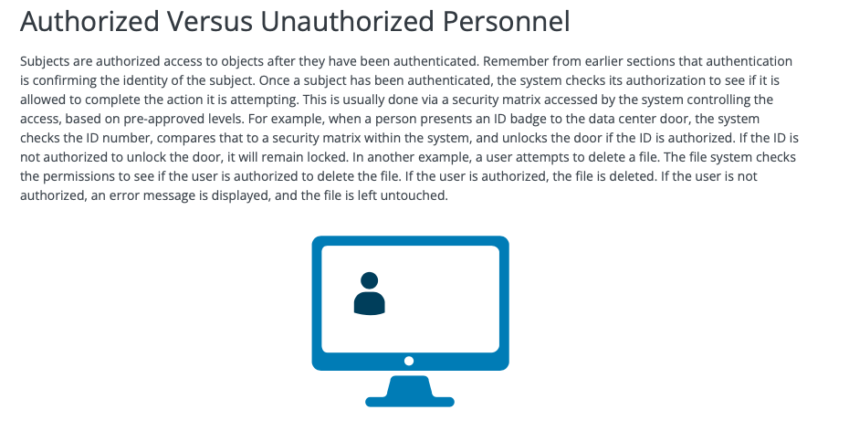

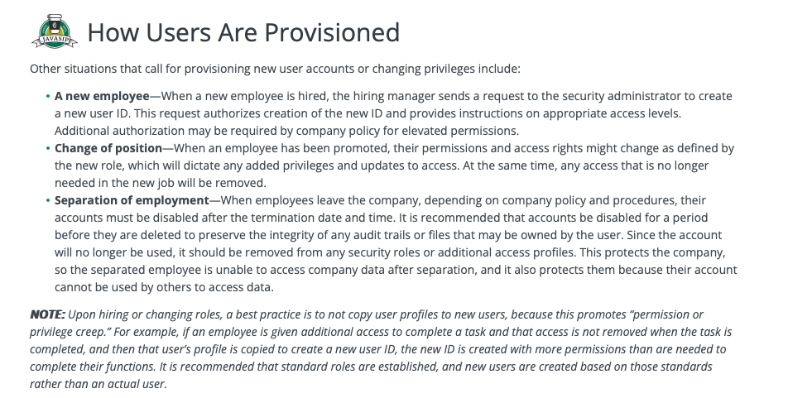

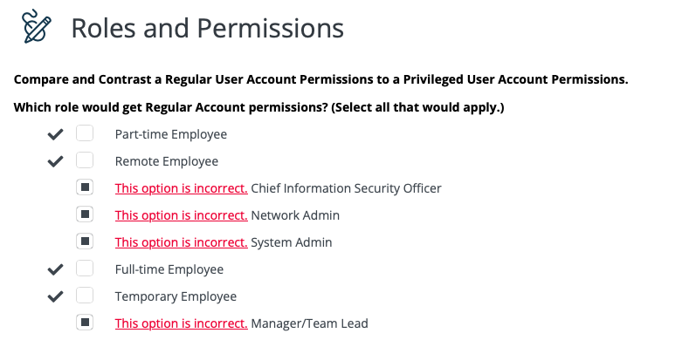

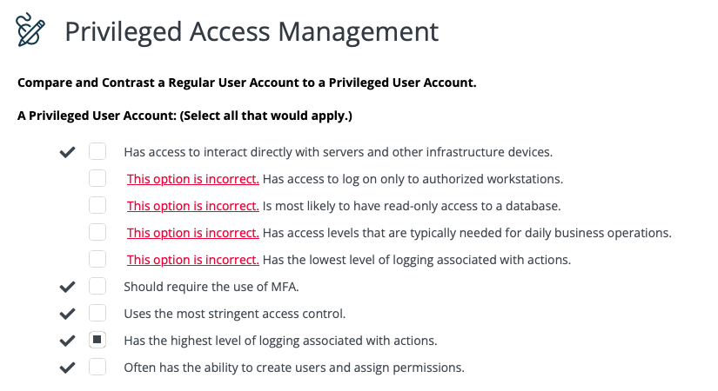

Benefits of Multiple Controls

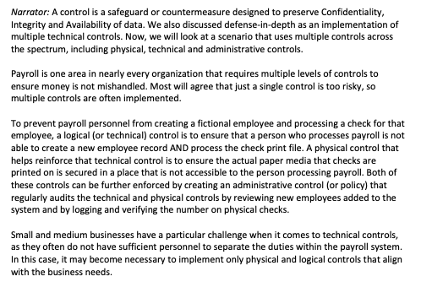

3.2: Understand Physical Access Controls

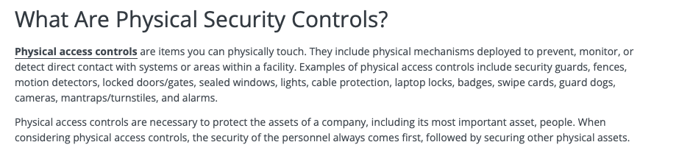

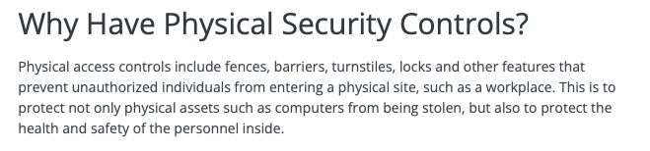

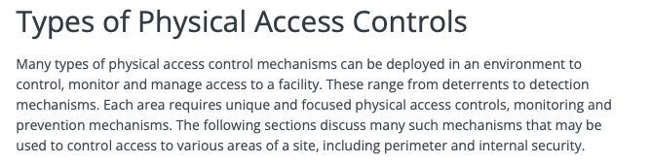

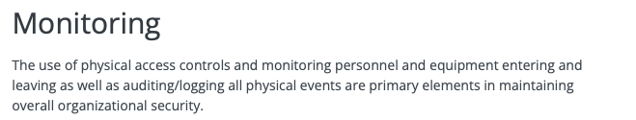

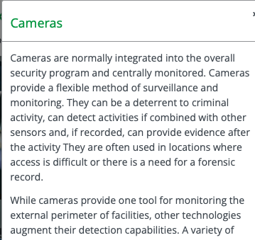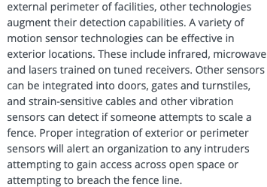

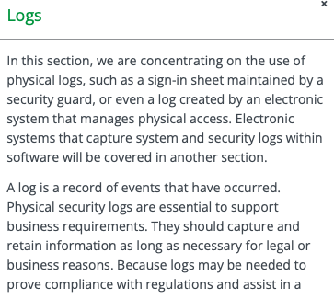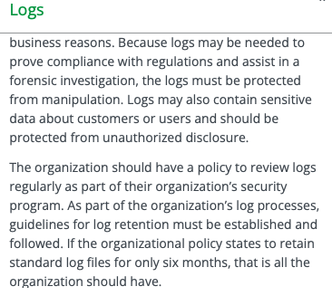

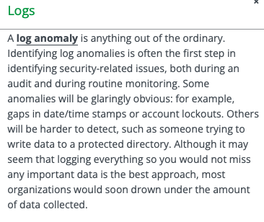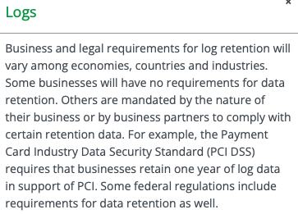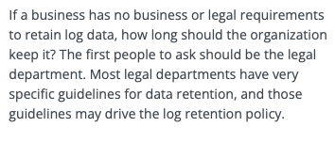

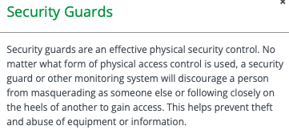

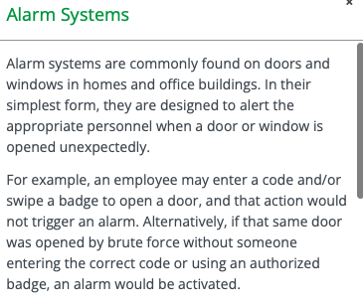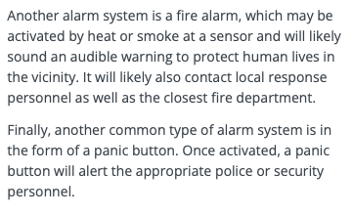

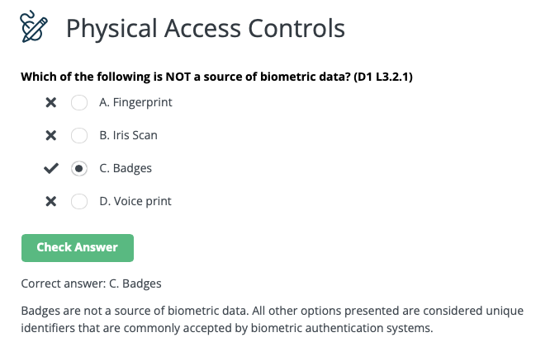

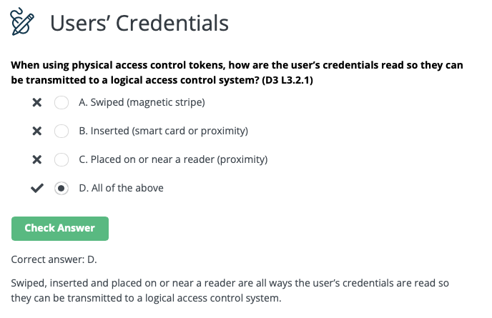

3.3: Understand Logical Access Controls

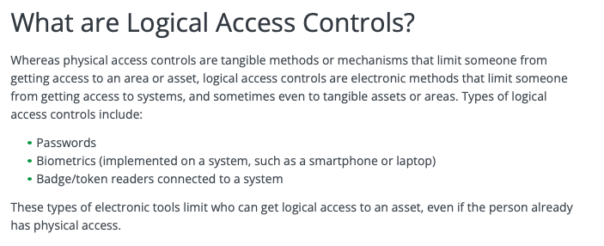

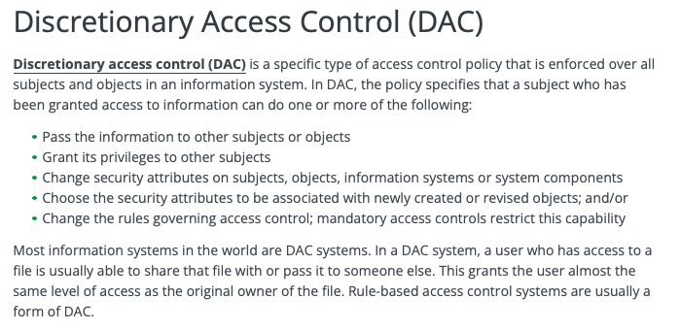

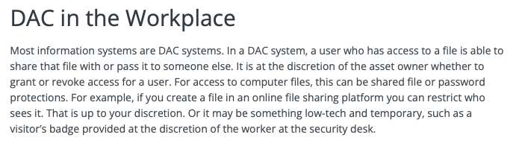

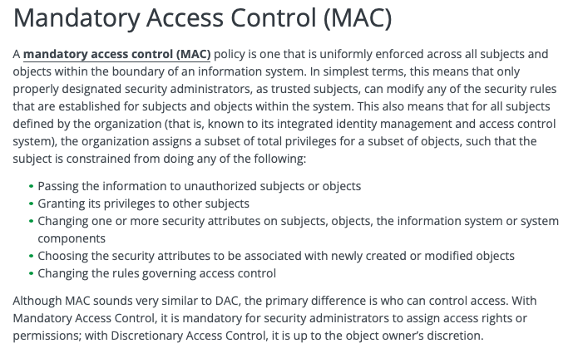

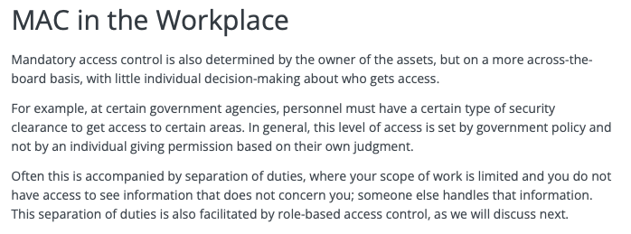

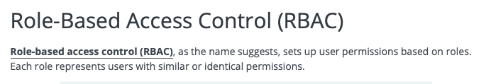

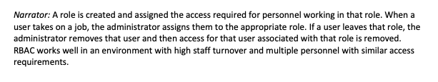

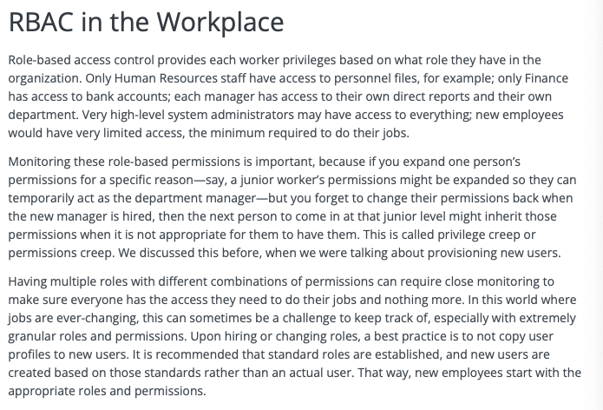

Chapter 3 Terms

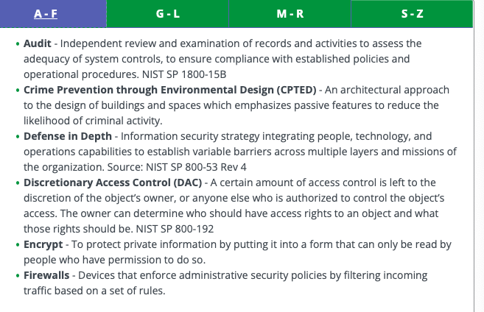

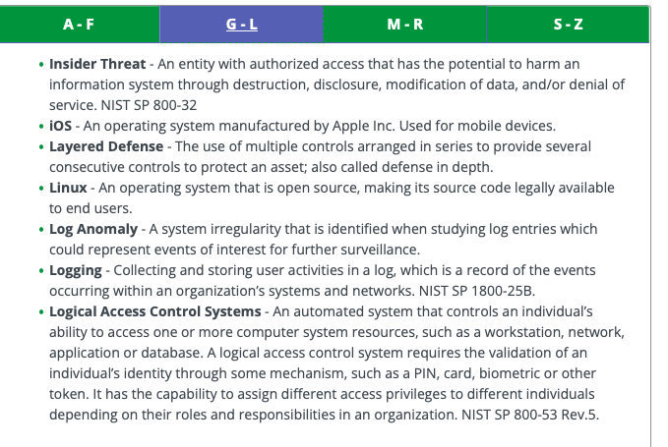

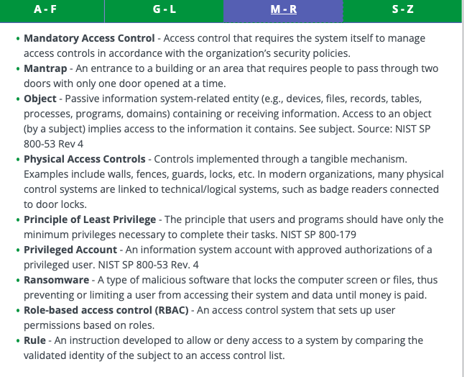

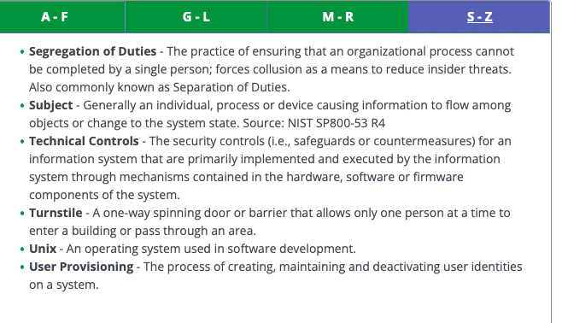

**END OF CHAPTER 3**

**Chapter 4: Network Security**

4.1-Understand Computer Networking

A network is simply two or more computers linked together to share data, information or resources

Two Basic Types of Networks:

1. LAN (Local Area Network): a network typically spanning a single floor or building
   * limited geographical area
2. WAN (Wide-Area Network): long-distance connection between geographically remote networks

Network Devices

Hubs: used to connect multiple devices in a network

* They’re less likely to be seen in business or corporate networks than in home networks
* Hubs are wired devices and are not as smart as switches or routers

Switch (“Intelligent Hub”): switches are wired devices that know the addresses of the devices connected to them and route traffic to that port/device rather than retransmitting to all devices

* Offering greater efficiency for traffic delivery and improving the overall throughput of data, switches are smarter than hubs, but not as smart as routers
* Switches can also create separate broadcast domains when used to create VLANS

Routers: used to control traffic flow on networks and are often used to connect similar networks and control traffic flow between them

* Routers can be wired or wireless and can connect multiple switches
* Smarter than hubs and switches, routers determine the most efficient “route” for the traffic to flow across the network

Other Network Terms

Ethernet (IEEE 802.3): standard that defines wired connections of networked devices

* This standard defines the way data is formatted over the wire to ensure disparate devices can communicate over the same cables

Device Address

Media Access Control (MAC) Address: every network devices is assigned a MAC address

Ex) 00-13-02-1F-58-F5

* The first 3 bytes (24 bits) of the address denote the vendor or manufacturer of the physical network interface
* No two devices can have the same MAC address in the same local network: otherwise an address conflict occurs

Internet Protocol (IP) Address: while MAC addresses are generally assigned in the firmware of the interface, IP hosts associate that address with a unique logical address

* This logical IPO address represents the network interface within the network and can be useful to maintain communications when a physical device is swapped with new hardware
* Ex) 192.168.1.1 and 2001:db8::ffff:0:1

Small Business Network Example

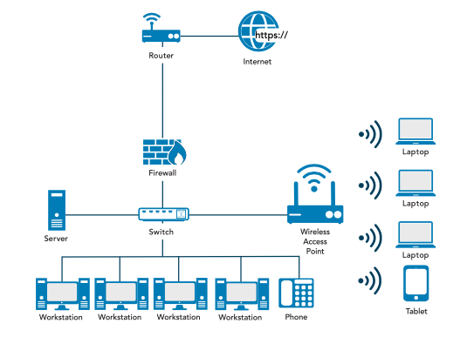

Home Network Example

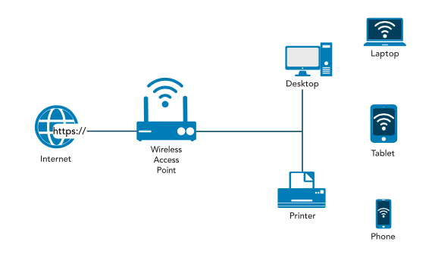

The purpose of all communications is to exchange information and ideas between people and organizations so that they can get work done

In network terms this is:

* Provide reliable, managed communciations between hosts and users
* Isolate functiosn in layers
* Use packets as the basis of communication
* Standardize routing, addressing and control
* Allow layers beyond internetworking to add functionality
* Be vendor-agnostic, scalable and resilient

In most basic form, a network model has at least two layers:

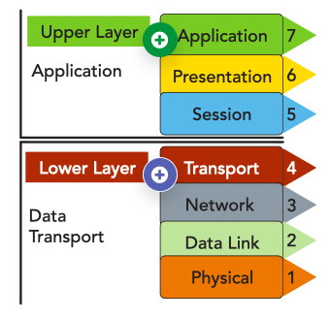

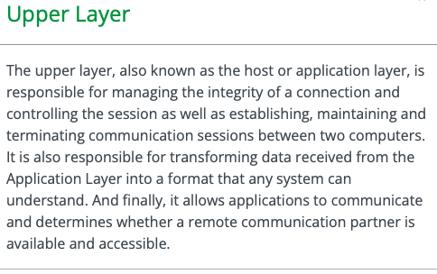

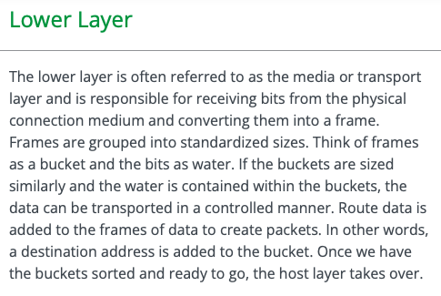

OSI (Open Systems Interconnection) Model

* The OSI model has become a common conceptual reference that is used to understand the communication of various hierarchical components from software interfaces to physical hardware
* Developed to establish a common way to describe the communication structure for interconnected computer systems
* The OSI model serves as an abstract framework, or theoretical model, for how protocols should function in an ideal world, on ideal hardware

The OSI model divides networking tasks into 7 distinct layers

* Each layer is responsible for performing specific tasks or operations with the goal of supporting data exchange (in other words, network communication) between two computers
* The layers are interchangeably referenced by name or layer number
* The layers are ordered specifically to indicate how information flows through the various levels of communication
* Each layer communicates directly with the layer above and below it
* Ex) layer 3 communicates with both data link (2) and transport (3) layer

The application, presentation, and session layers (5-7) are commonly referred to simply as data

* Each layer has the potential to perform encapsulation

Encapsulation: the addition of header and possibly a footer (trailer) data by a protocol used at that layer of the OSI model

* Encapsulation is particularly important when discussing Transport, Network and Data Link Layers (2-4), which all generally include some form of header
* Encapsulation occurs as the data moves down the OSI model from application to physical
* As data is encapsulated at each descending layer, the previous layer’s header, payload and footer are all treated as the next layer’s payload
* The data unit size increases as we move down the conceptual model and the contents continue to encapsulate
* The inverse action occurs as data moves up the OSI model layers from physical to application (**de-encapsulation)**

The header and footer are used to properly interpret the data payload and are then discarded

* As we move up the OSI model, the data unit becomes smaller

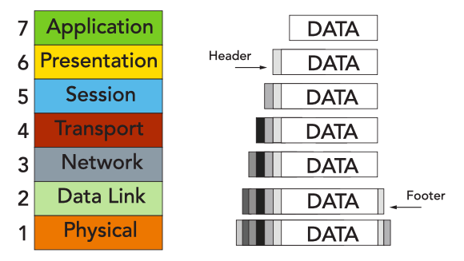

At the physical layer (1), the data unit is converted into binary and sent across physical wires such as an ethernet cable

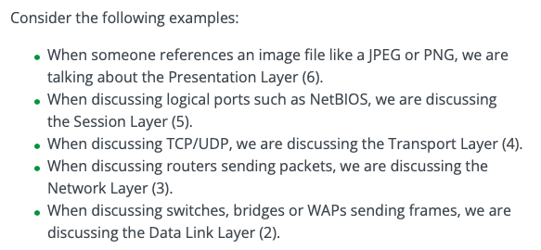

Transmission Control Protocol/Internet Protocol (TCP/IP)

* The OSI model wasn’t the first or only attempt to streamline networking protocols or establish a common communications standard
* The most widely used protocol, TCP/IP was developed in the early 1970s
* OSI model was developed in late 1970s

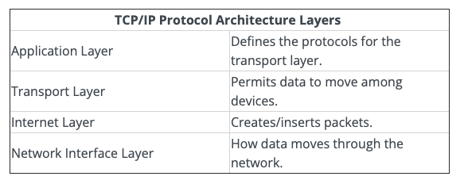

The TCP/IP Protocol is a stack protocol comprised of dozens of individual protocols

* TCP/IP is a platform-independent protocol based on open standards
  + TCP/IP can be found in every available operating system, but it consumes a significant amount of resources and is relatively easy to hack into b/c it was designed for ease of use rather than for security

At the Application Layer, TCP/IP protocols include Telnet, File Transfer Protocol (FTP), Simple Mail Transport Protocol (SMTP), and Domain Name Service (DNS)

The Two primary Transport Layer protocols of TCP/IP are:

1. TCP: is a full-duplex connection-oriented protocol
2. UDP: a simplex connectionless protocol

In the internet Layer, Internet Control Message Protocol (ICMP) is used to determine the health of a network or a specific link

* ICMP is utilized by ping, tracerout and other network management tools
* Ping utility employs ICMP echo packets and bounces them off remote systems
* Thus, you can use ping to determine whether the remote system is online, whether the remote system is resonding promptly, whether the intermediary systems are supporting communications, and the level of performance efficiency at which the intermediary systems are communicating

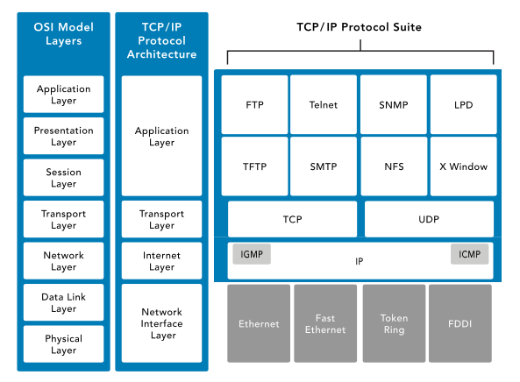

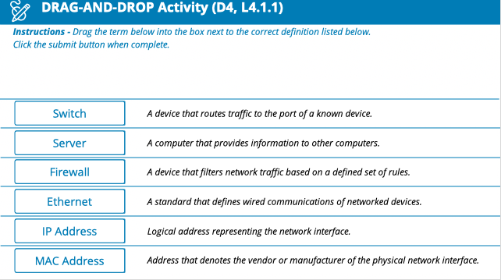

Internet Protocol (IPv4 and IPv6)

IP is used worldwide in two major versions:

1. IPv4: provides a 32-bit address space 🡪 was expected to be exhausted by 1980s
2. IPv6: provides a 128-bit address space along with several other important features 🡪 introduced in December 1995

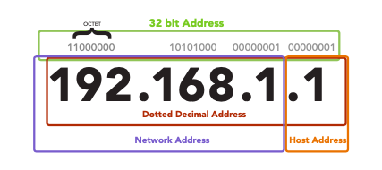

IP Hosts/Devices associate an address with a unique logical address

IPv4 Address

* Expressed as four octet/4bytes/32bits may have a value between 0 and 255
* However, 0 is the network itself (not a device on that network), and 255 is generally reserved for broadcast purposes
* Each address is subdivided into two parts:
  + A) Network Number: assigned by external organization, such as the Internet Corporation for Assigned Names and Numbers (ICANN): represents organization’s network
  + B) Host: represents the network interface within the network

To ease network administration, networks are typically divided into subnets

* b/c subnets CANT be distinguished with the addressing scheme, a separate mechanism, the subnet mask, is used to define the part of the address used for the subnet
* the mask is usually converted to decimal notation like 255.255.255.0
* with the ever-increasing number of computers and networked devices, it is clear that IPV4 does NOT provide enough addresses for our needs
* To overcome this shortcoming, IPv4 was sub-divided into public and private address ranges
* Public addresses are limited with IPv4, but this issue was addressed in part with private addressing
* Private addresses can be shared by anyone, and it is highly likely that everyone on your street is using the same address scheme

The nature of the addressing scheme established by IPv4 meant that network designers had to start thinking in terms of IP address reuse

* IPv4 facilitated this in several ways, such as its creation of the private address groups; this allows every LAN in every SOHO (small office, home office) situation to use addresses such as 192.168.2.xxx for its internal network addresses, without fear that some other systems can intercept traffic on their LAN

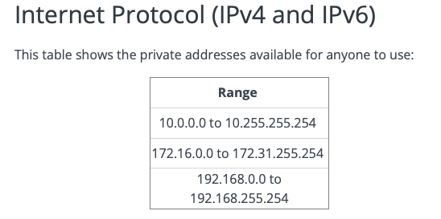

* The first octet of 127 is reserved for computer’s loopback address
* Usually, the address 127.0.0.1 is used
* The loopback address is used to provide a mechanism for self-diagnosis and troubleshooting at the machine level
* This mechanism allows a network administrator to treat a local machine as if it were a remote machine and ping the network interface to establish whether it is operational

IPv6 is a modernization of IPv4, which addressed a number of weaknesses in the IPv4 environment:

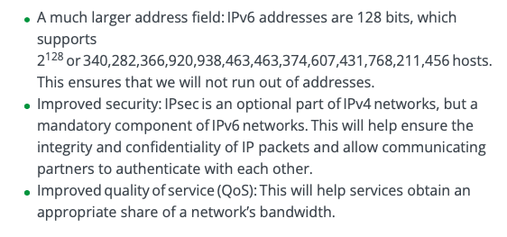

IPv6:

* IPv6 Address is shown as 8 groups of four digits
* Instead of numeric (0-9) digits like IPv4, IPv6 addresses use the hexadecimal range (0000-ffff) and are separated by colons (:) rather than periods (.)
* An example is 2001:0db8:0000:0000:0000:ffff:0000:0001
* To make it easier for human to read and type, it can be shortened by removing the leading zeros at the beginning of each fild and substituting two colons (:: ) for the longest consecutive zero fields
* All fields must retain at least one digit
* After shortening, the example address above is rendered as 2001:db8::ffff:0:1

For IPv4, there are some addresses and ranges that are reserved for special users:

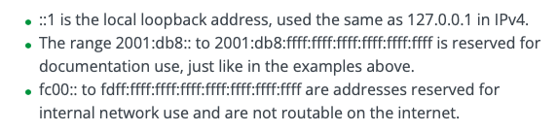

WIFI

* Wireless networking is a popular method of connecting corporate and home systems b/c of the ease of deployment and relatively low cost
* It has made networking more versatile than ever before
* Workstations and portable systems are no longer tied to a cable but can roam freely within the signal range of the deployed wireless access points
* However, with this freedom comes additional vulnerabilities

WI-FI range is generally wide enough for most homes or small offices, and range extenders may be placed strategically to extend the signal for larger campuses or homes

* Over time the WI-Fi standard has evolved, with each updated version faster than the last

In a LAN, threat actors need to enter the physical space or immediate vicinity of the physical media itself

* For wired networks, this can be done by placing sniffer taps onto cables, plugging in USB devices, or using other tools that require physical access to the network
* By contrast, wireless media intrusions can happen at a distance

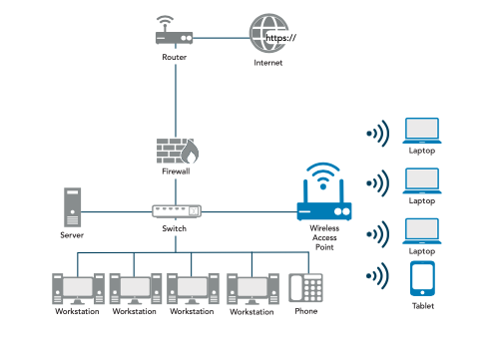

Security of the Network

* TCP/IP’s vulnerabilities are numerous
* Improperly implemented TCP/IP stacks in various operating systems are vulnerable to various DoS/DDoS attacks, fragment attacks, oversized packet attacks, spoofing attacks, and man-in-the-middle attacks
* TCP/IP is also subject to passive attacks via monitoring or sniffing
* Network monitoring, or sniffing, is the act of monitoring traffic patterns to obtain information about a network

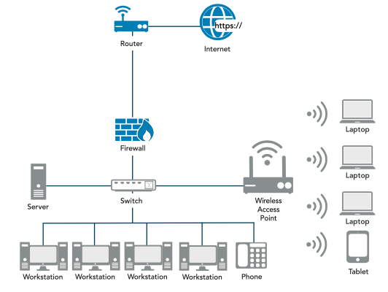

Ports and Protocols (Applications/Services)

Physical ports: connect to wires

Logical ports: determine where the data/traffic goes

Physical Port

* Ports on routers, switches, servers, computers etc. that you connect wires
* Ex) fiber optic cables, Cat5 cables etc. to create a network
* 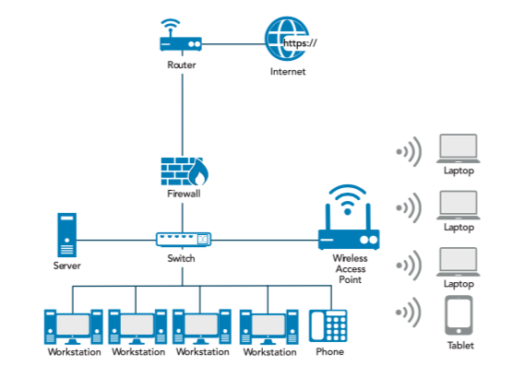

Logical Ports

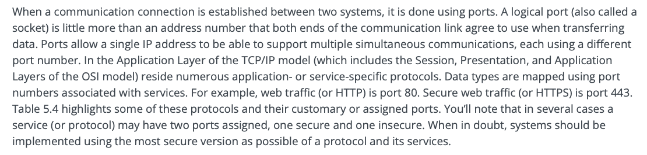

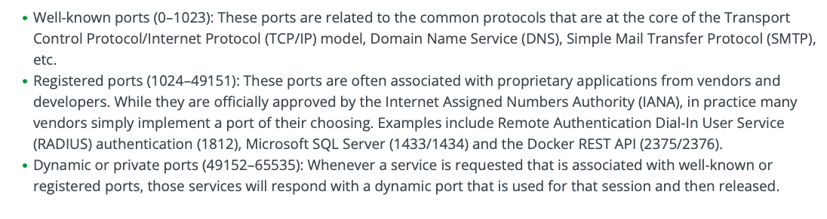

Secure Ports

* Some network protocols transmit information in clear text, meaning it is not encrypted and should not be used
* Clear text information is subject to network sniffing
* This tactic uses software to inspect packets of data as they travel across the network and extract text such as usernames and passwords
* Network sniffing could also reveal the content of documents and other files if they are sent via insecure protocols

Port Examples

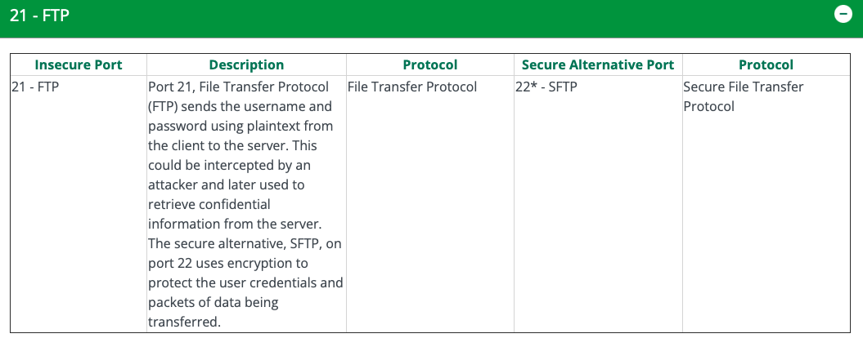

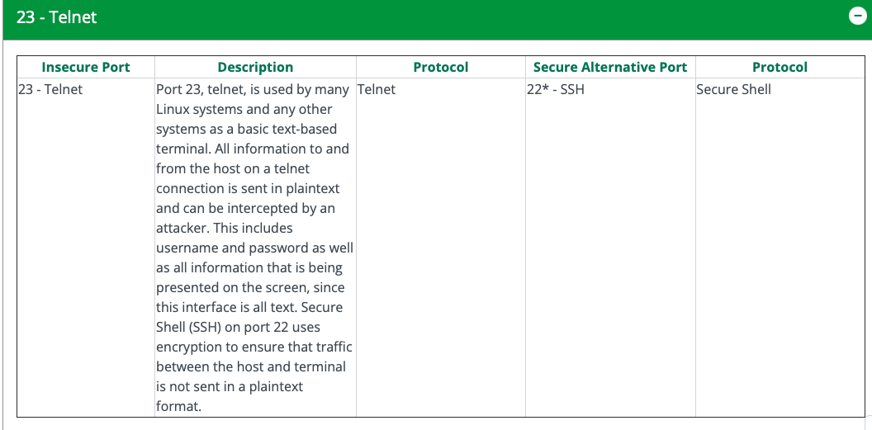

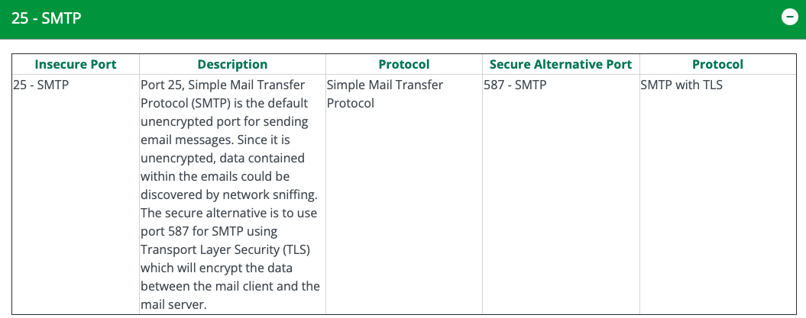

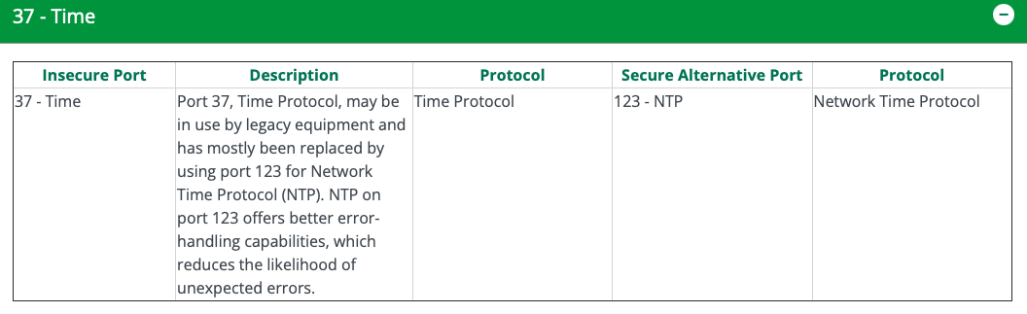

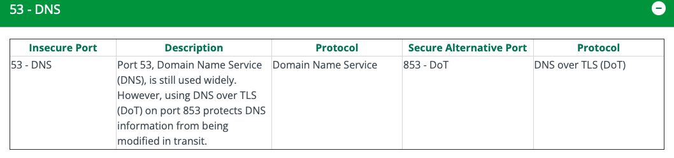

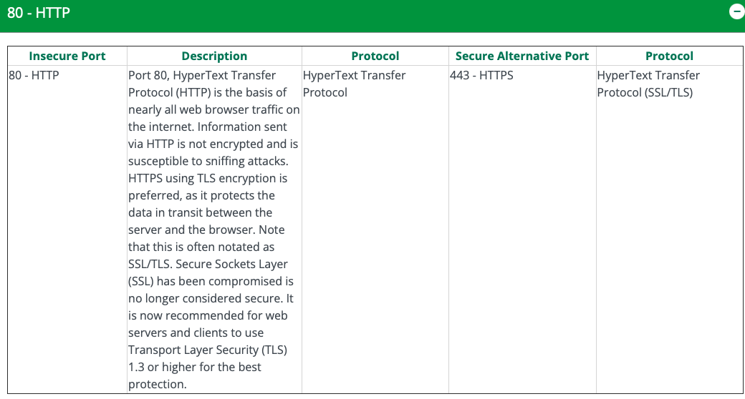

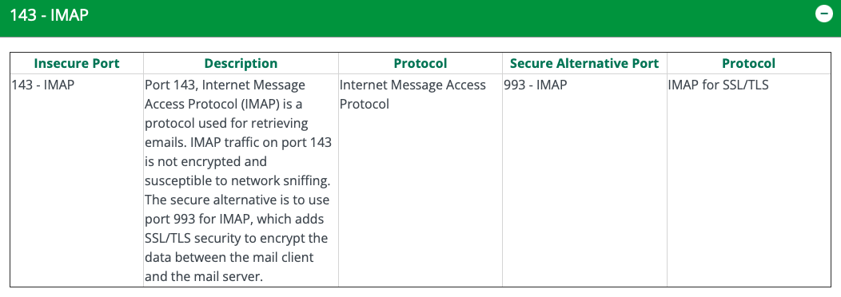

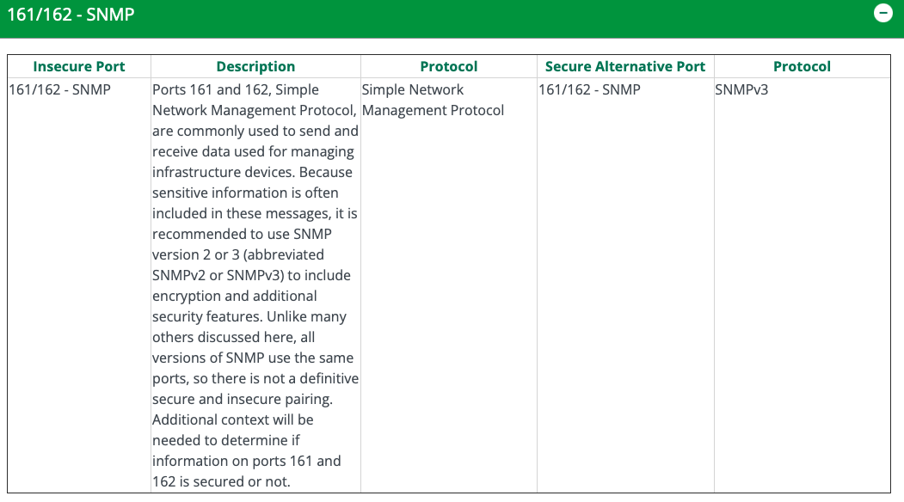

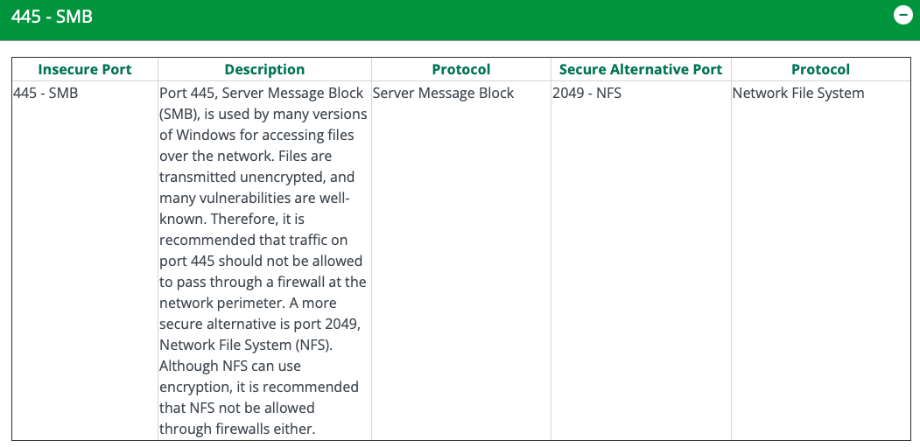

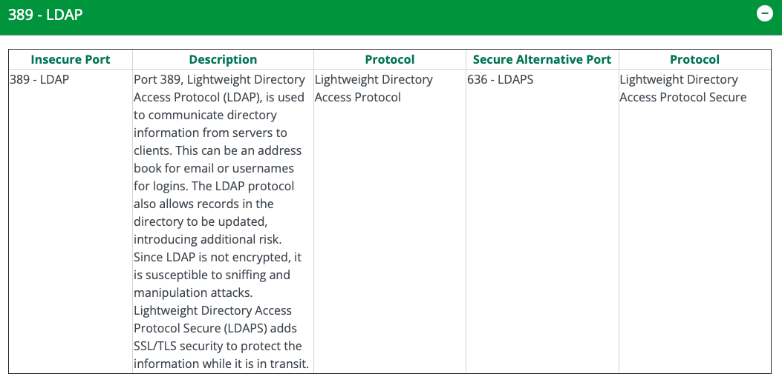

SYN, SYN-ACK Video

Between a client and server there is a system for synchronizing and acknowledging any request that is known as a three-way handshake

* Used to establish a TCP connection between two devices

1. First client sends a synchronization (SYN) packet to the web server’s port 80 or 443 🡪 request to establish a connection
2. The web server replies to the SYN packet with an acknowledgement known as SYN/ACK
3. Finally, the client acknowledges the connection with an acknowledgement (ACK) 🡪 at this point, the basic connection is established, and the client and host will further negotiate secure communications over that connection

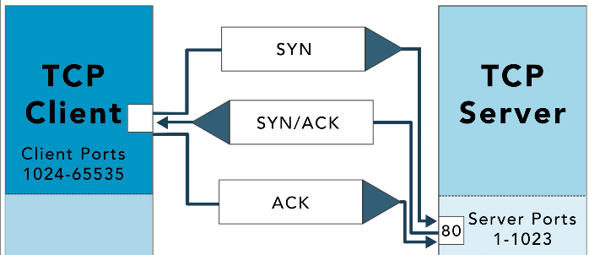

LDAP: is used to exchange directory information in a secured protocol

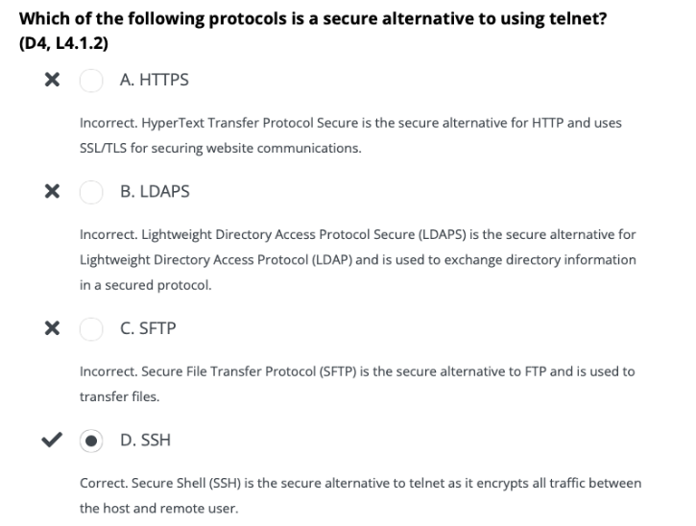

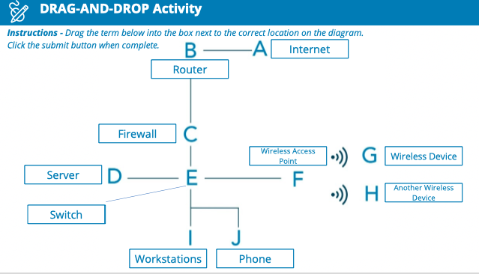

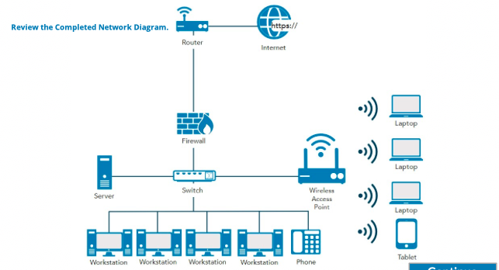

4.2- Understand Network (Cyber) Threats and Attacks

Types of Threats

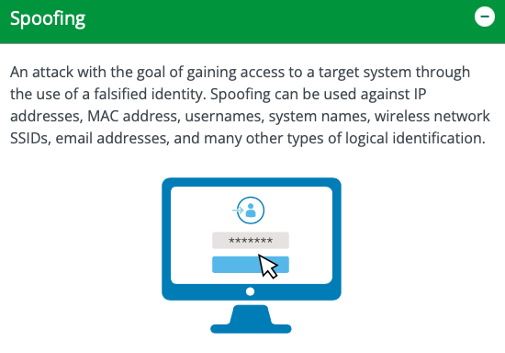

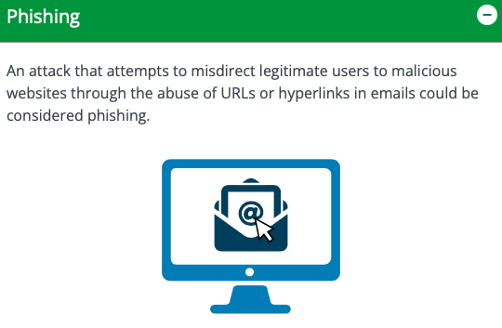

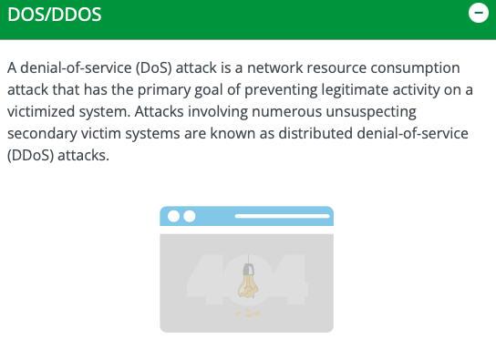

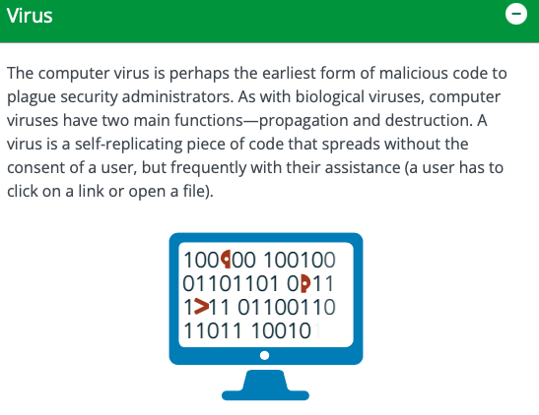

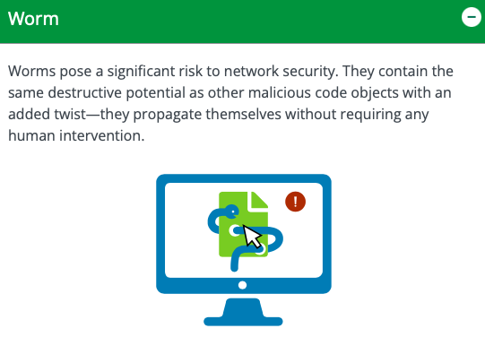

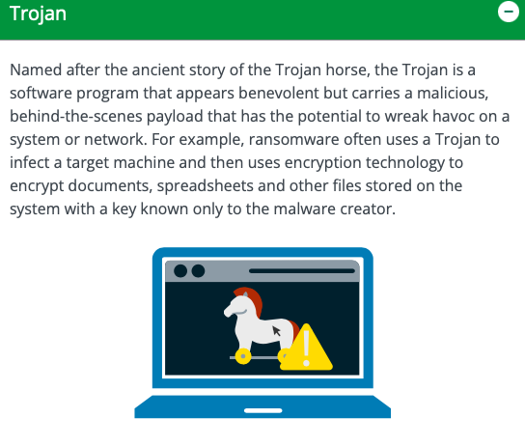

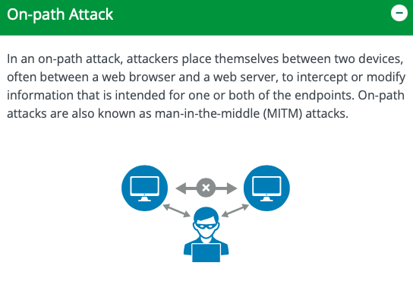

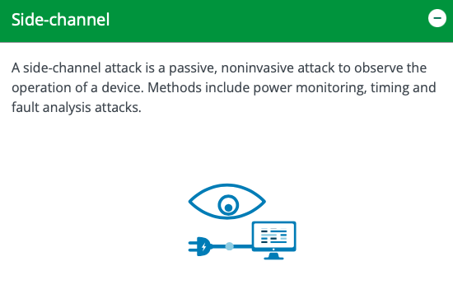

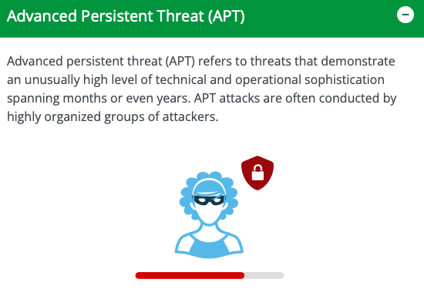

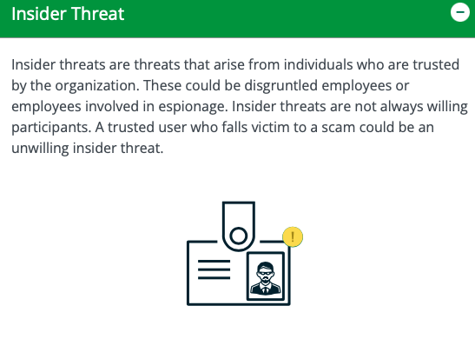

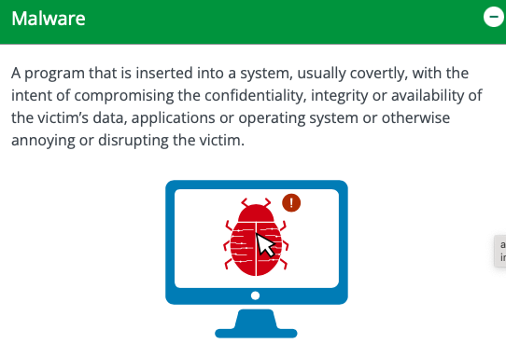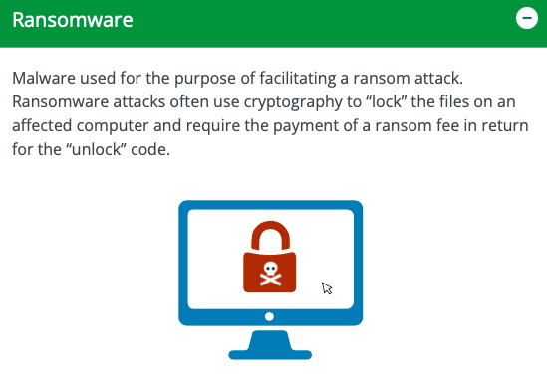

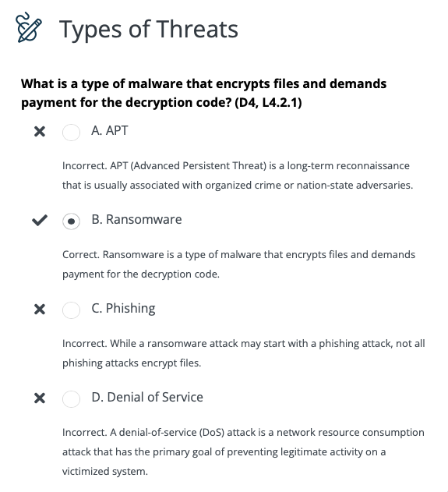

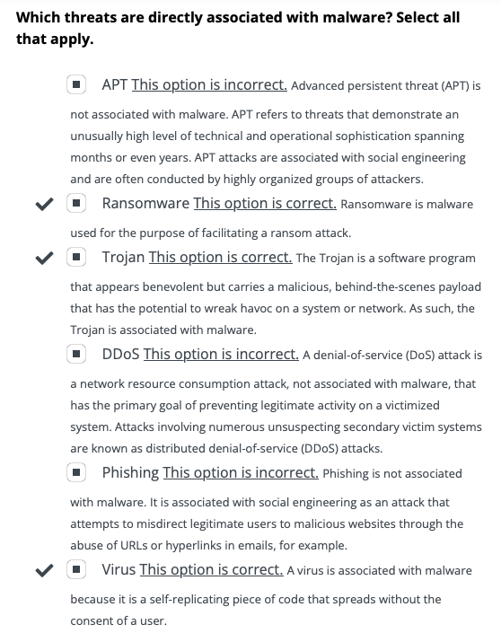

Examples of Ways to Protect a Network:

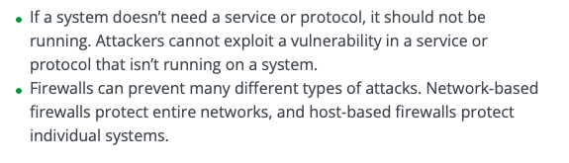

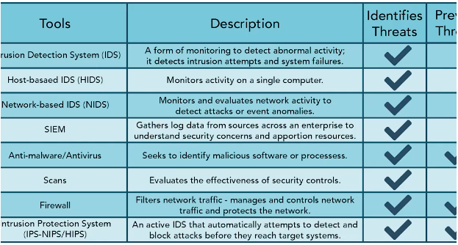

IDS (Intrusion Detection System)

* An intrusion occurs when an attacker is able to bypass or thwart security mechanisms and gain access to an organization’s resources
* Intrusion detection is a specific form of monitoring that monitors recorded information and real-time events to detect abnormal activity, indicating a potential incident or intrusion
* An intrusion detection system (IDS) automates the inspection of logs and real-time system events to detect intrusion attempts and system failures
* An IDS is intended as part of a defense-in-depth security plan
* It works with and complements other security mechanisms such as firewalls, but it does NOT replace them
* IDS can recognize attacks that come from external connections, such as an attack from the internet, and attacks that spread internally, such as a malicious worn
* One they detect a suspicious event, they respond by sending alerts or raising alarms
* A primary goal of an IDS is to provide a means for a timely and accurate response to intrusions
* Intrusion detection and prevention refer to capabilities that are part of isolating and protecting a more secure or more trusted domain or zone from one that is less trusted or less secure
* These are natural functions to expect of a firewall, for example
* IDS types are commonly classified as host-based and network-based

HIDS (Host-Based IDS): monitors a single computer or host

NIDS (Network-Based IDS): monitors a network by observing network traffic patterns

Identifying Threats

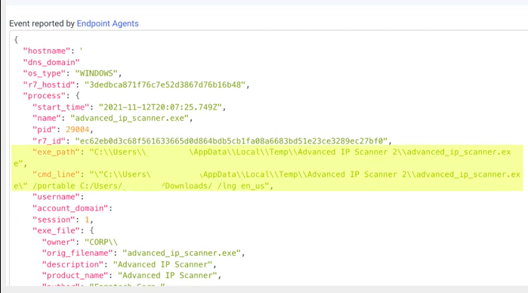

PID:

Lower number: indicates file executed near time of operating system booted

High number: indicates file executed way after computer was started

Preventing Threats

* Keep systems and applications up to date
  + Vendors regularly release patches to correct bugs and security flaws, but these only help when they are applied
  + Patch management ensures that systems and applications are kept up to date with relevant patches
* Remove or disable unneeded services and protocols
  + If a system doesn’t need a service or protocol, it should not be running
  + Attackers CANT exploit a vulnerability in a service or protocol that isn’t running on a system
  + As an extreme contrast, imagine a web server is running every available service and protocol 🡪 it is vulnerable to potential attack son any of these services and protocols
* Use intrusion detection and prevention systems
  + IDS and IPS observe activity, attempt to detect threats, provide alerts, block or stop attacks
* Use up-to-date anti-malware software
* Use firewalls
  + Firewalls can prevent many different types of threats
  + Network-based firewalls protect entire networks, and host-based firewalls protect individual systems

Firewalls: prevent threats by filtering network traffic based on rules

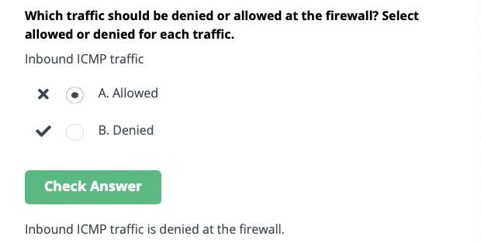

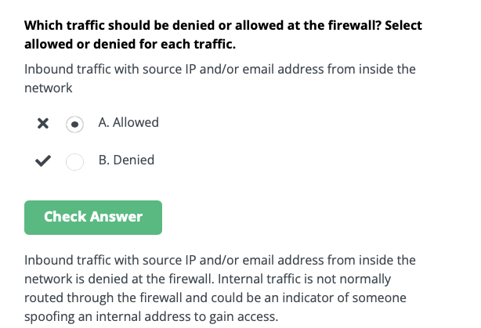

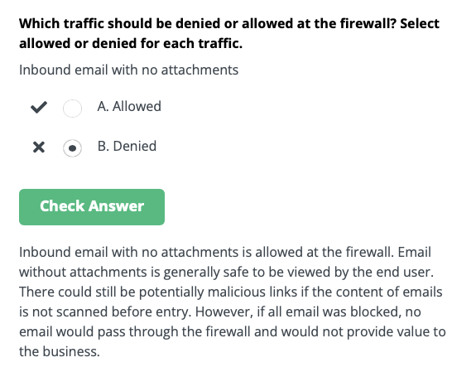

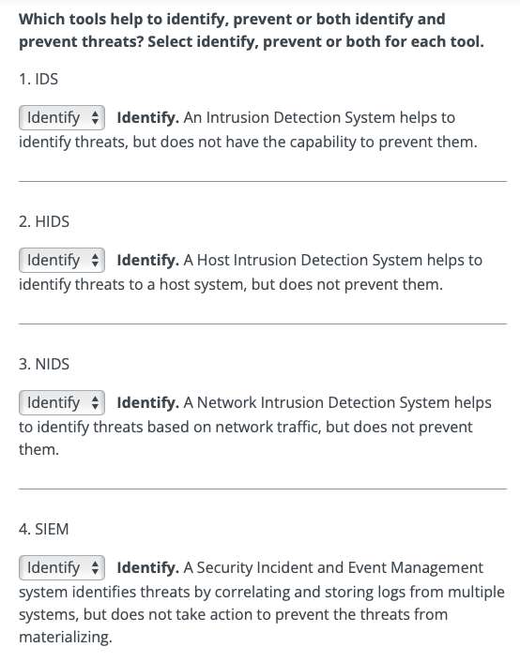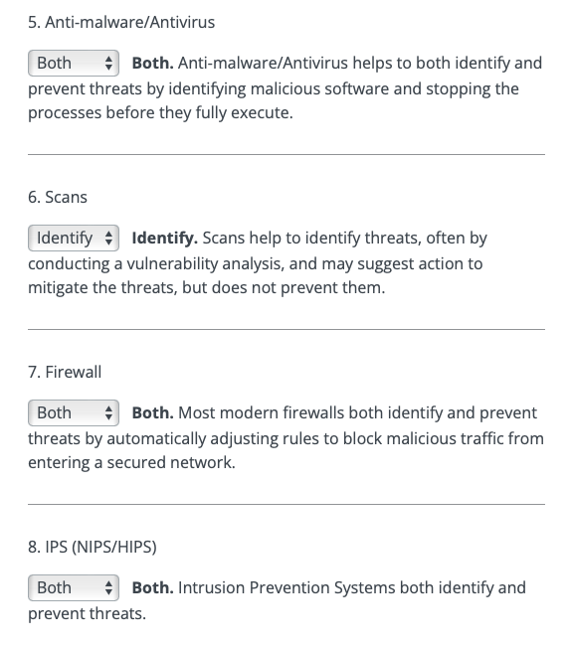

4.3- Understanding Network Security Infrastructure

On-Premise Data Centers:

When it comes to data centers, there are two primary options:

1. Organizations can outsource the data center
2. Organizations can own the data center
   * If the data center is owned, it will likely be built on premises
   * A place like a building for the data center is needed, along with power, HVAC, fire suppression and redundancy

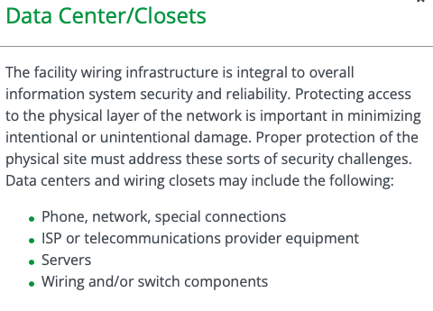

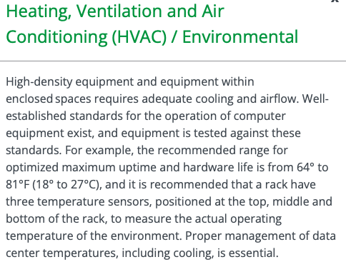

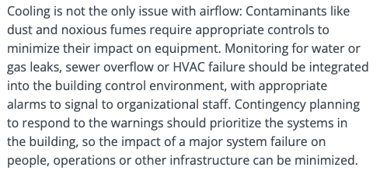

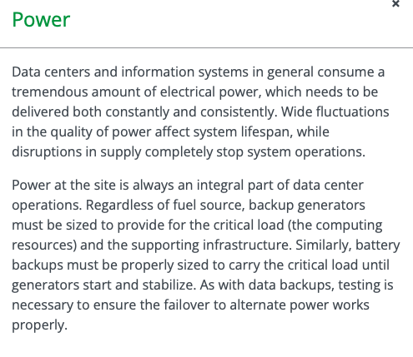

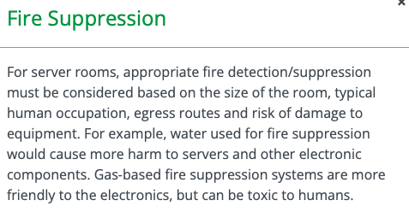

Servers and other equipment generate a lot of heat 🡪 AC requirements

* Most equipment shut down when reach certain temperatures
* Abnormal shut down of equipment can lead to loss or corruption of data

Water and electricity DON’T mix

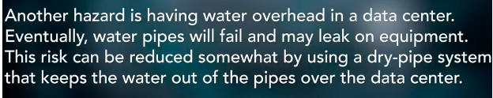

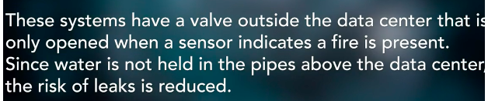

Redundancy

Redundancy: designing systems with duplicate components so that if a failure were to occur, there would be a backup

* This can apply to the data center as well
* Risk assessments pertaining to the data centre should identify when multiple separate utility service entrances are necessary for redundant communication channels and/or mechanisms

If the organization requires full redundancy, devices should have two power supplies connected to diverse power sources

* Those power sources would be back up by batteries and generators
* In high-availability environment, even generators would be redundant and fed by different fuel types

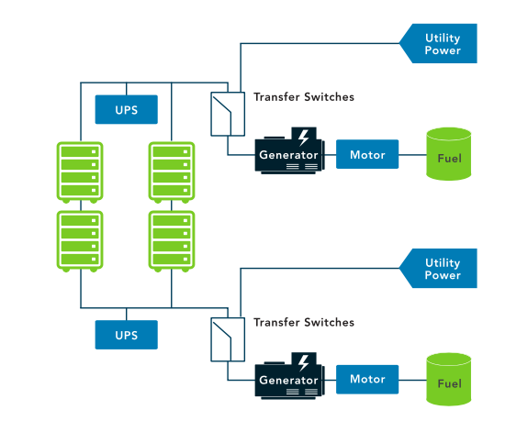

In additions to redundant backups of information, you also have redundant sources of power to provide backup power so you have an uninterrupted power supply (UPS)

* Transfer switches/transformers may also be involved
* Back-up generators are essential in situations of black-out or weather
* Often there will be two generators connected by two different transfer switches
  + These generators might be powered by diesel or gasoline or another fuel such as propane, or even by solar panels
  + A hospital or essential government agency might contract with more than one power company and be on two different grids in case one goes out 🡪 redundancy

Memorandum of Understanding (MOU)/ Memorandum of Agreement (MOA)

Some organizations seeking to minimize downtime and enhance BC (business continutity) and DR (Disaster Recover) capabilits will create agreements with other, similar organizaitons

* They agree that if one of the parties experiences an emergency and CANT operate within their own facilyt, the other party will share its resources and let them operate within theirs in order to maintain critical functions
* These agreements often even include competitors b/c their facilites and resources meet the needs of their particular industry

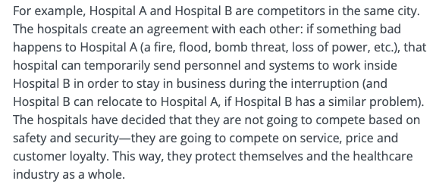

These agreements are called joint operating agreements (JOA) or memoranda of understanding (MOU) or memoranda of agreement (MOA)

* Sometimes these agreements are mandated by regulatory requirements, or they might just be part of the administrative safeguards instituted by entity within the guidelines of its industry

The difference between an MOA or MOU and an SLA is that a memorandum of understanding is more directly related to what can be done with a system or the information

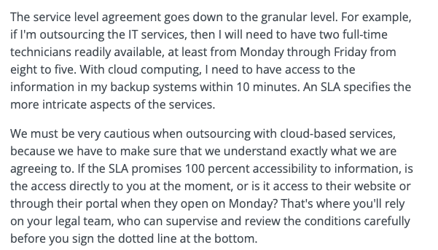

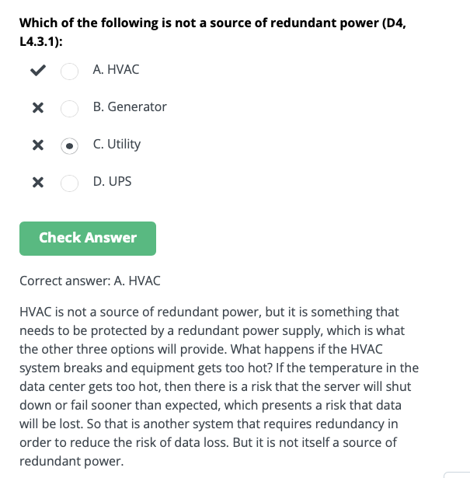

Cloud

Cloud computing: usually associated with an internet-based set of computing resources and typically sold as a service, provided by a cloud service provider (CSP)

Cloud computing is very similar to the electrical or power grid

* It is provisioned in a geographical location and is sourced using an electrical means that is not necessarily obvious to the consumer
* But, when you want electricity, it’s available to you via a common standard interface and you pay only for what you use
* Cloud computing is very scalable, elastic and easy-to-use “utility” for the provisioning and deployment of information Technology (IT) services

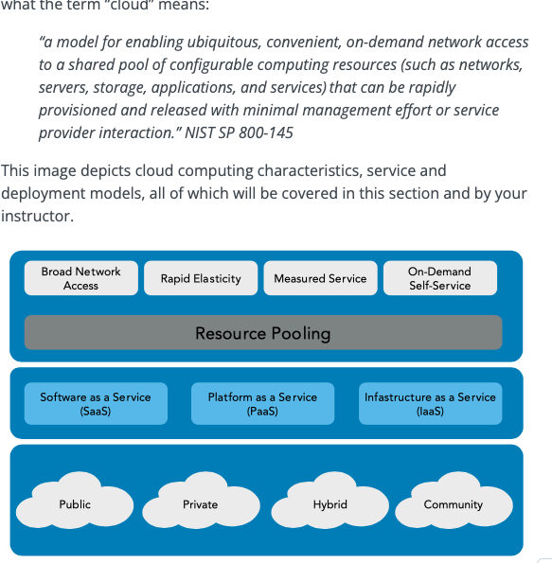

Cloud Characteristics

Cloud-based assets include any resources that an organization accesses using cloud-computing

* Cloud computing: refers to on-demand access to computing resources available from almost anywhere, and cloud computing resources are highly available and easily scalable
* Organizations typically lease cloud-based resources from outside the organization
* Cloud computing has many benefits for organizations, which include but are not limited to:

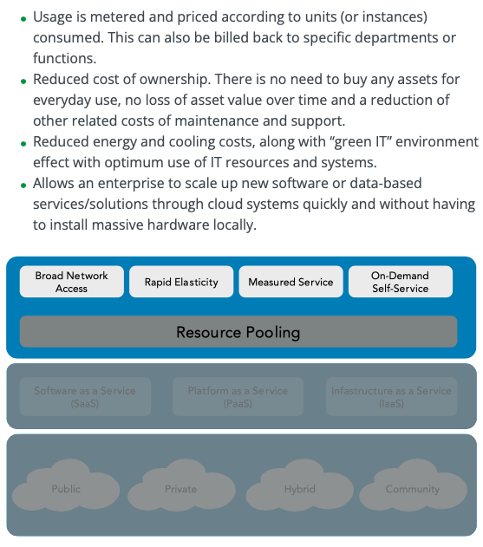

Service Models

Some cloud-based services only provide data storage and access

* When storing data in the cloud, organizations must ensure that security controls are in place to prevent unauthorized access to the data

There are varying levels of responsibility for assets depending on the service model

This includes:

* Maintaining the assets
* Ensuring they remain functional
* Keeping the systems and applications up to date with current patches

In some cases the CSP is responsible, and in other cases the consumer is responsible for these steps

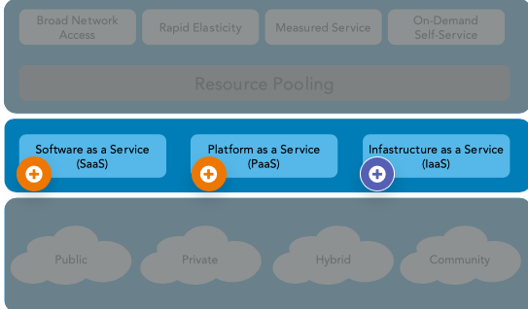

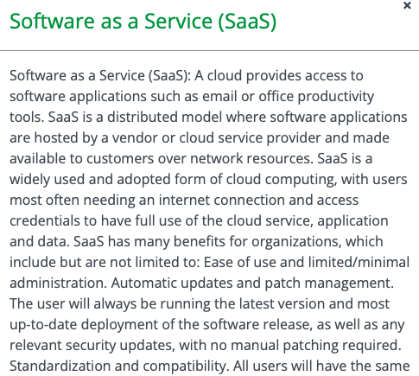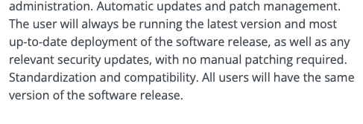

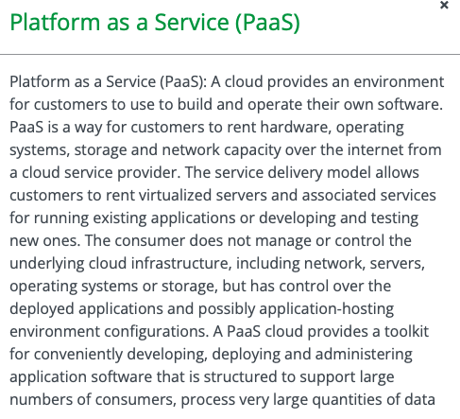

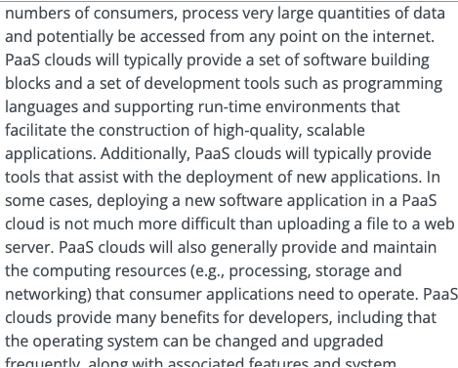

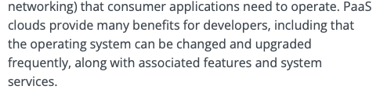

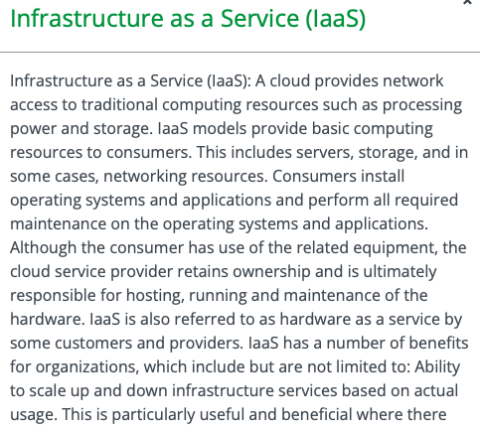

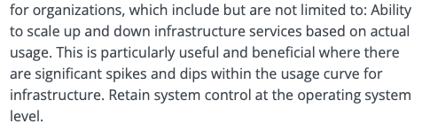

Deployment Models

There are four cloud-deployment models

* They also affect the breakdown of responsibilities of the cloud-based assets

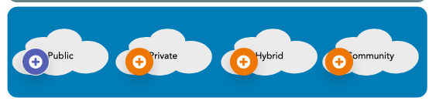

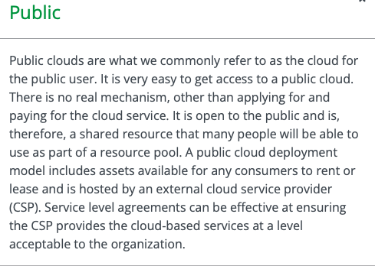

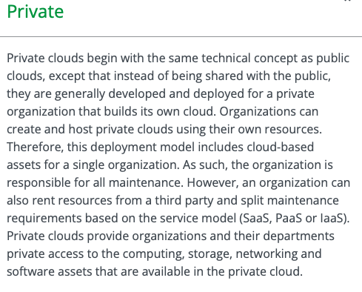

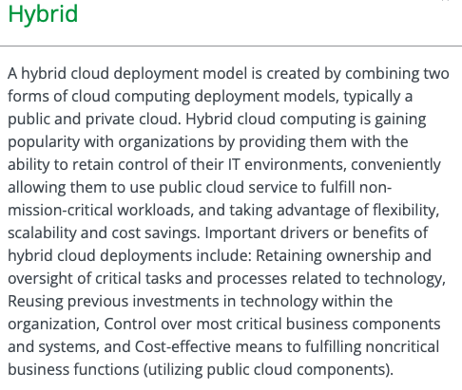

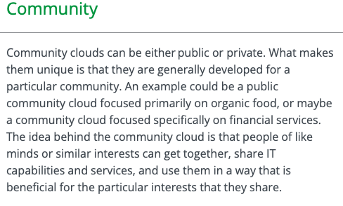

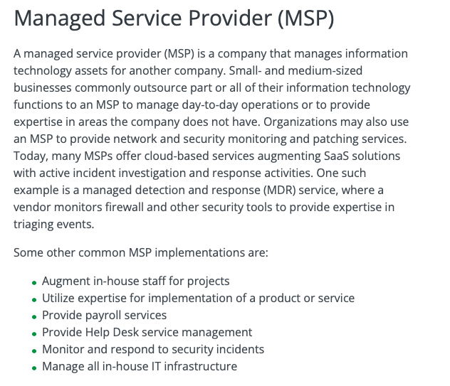

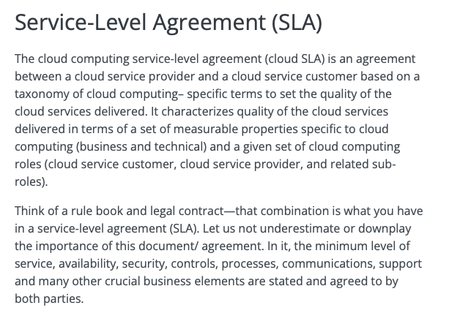

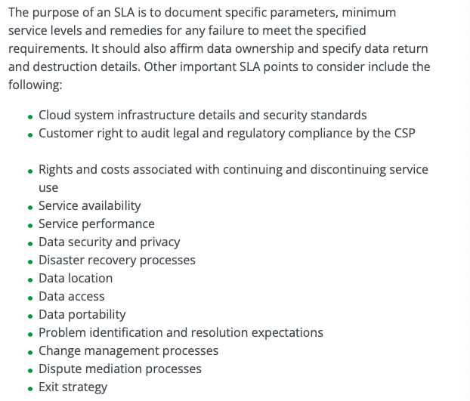

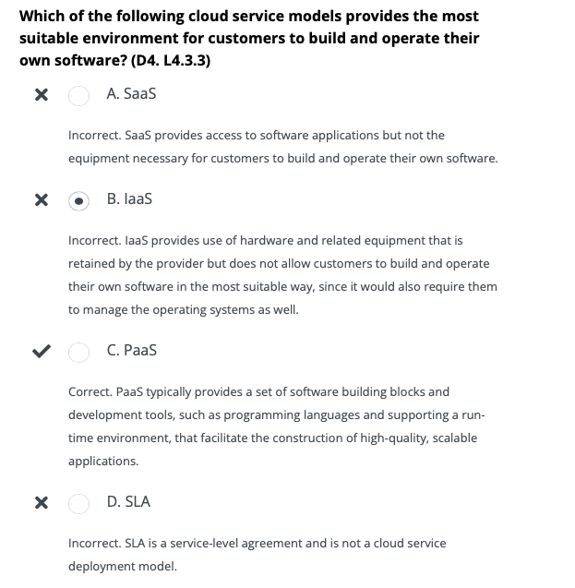

Network Design

The objective of network design is to satisfy data communication requirements and results in efficient overall performance

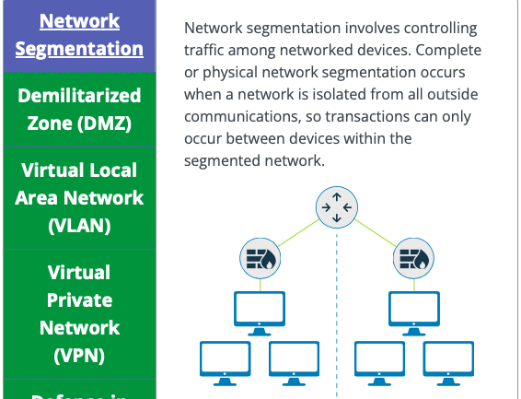

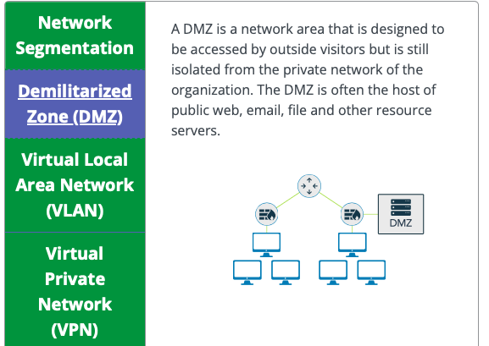

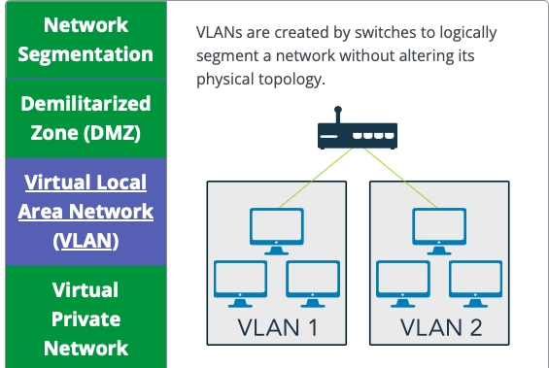

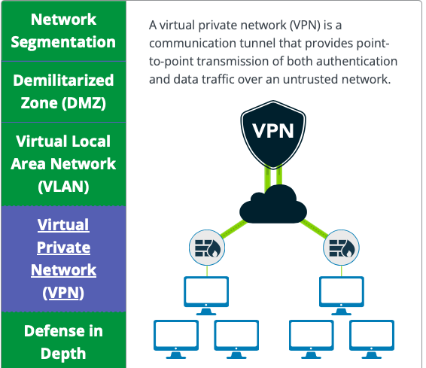

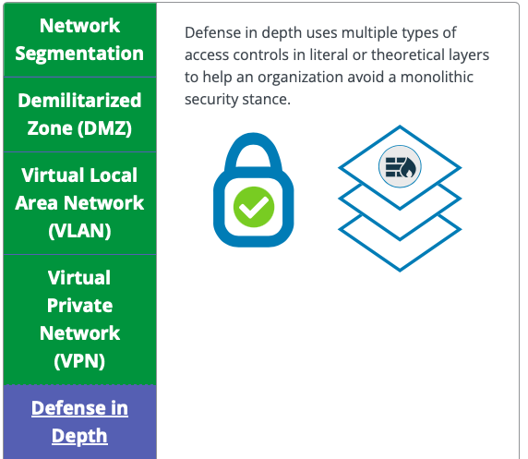

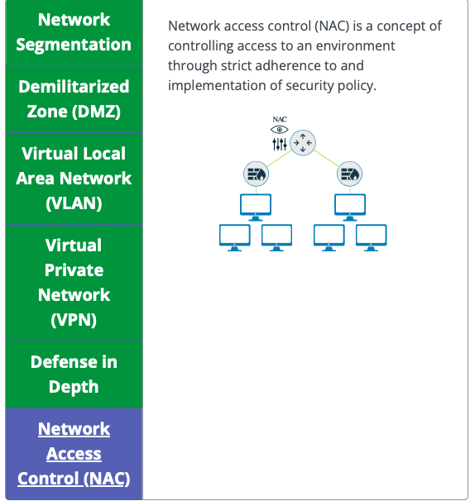

Defense in Depth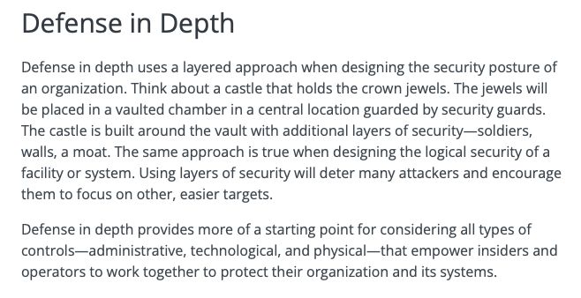

Defense in Depth Concepts

Data: Controls that protect the actual data with technologies such as encyrption, data leak prevention, identity and access management and data controls

Application: controls that protect the application itself with technolgies such as data leak prevention, application firewalls and database monitors

Host: every control that is placed at the endpoint level, such as antivirus, endpoint firewalls, configuration and patch management

Internal Network: controls that are in place to protect uncontrolled data flow and user access across the organizational network. Relevant technolgies include intrusion detection systems, intrusion prevention systems, internal firewalls and network access controls

Perimeter: controls that protect against unauthorized access to the network. This level includes the use of technologies such as gateway firewalls, honeypots, malware analysis, and secure demilitarized zones (DMZs)

Physical: controls that provide a physical barrier, such as locks, walls or access controls

Policies, Procedures, Awareness: Administrative controls that reduce insider threats (intentially and unintentional) and identify risks as soon as they appear

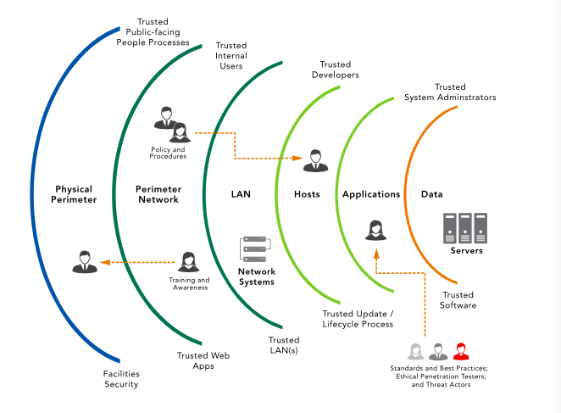

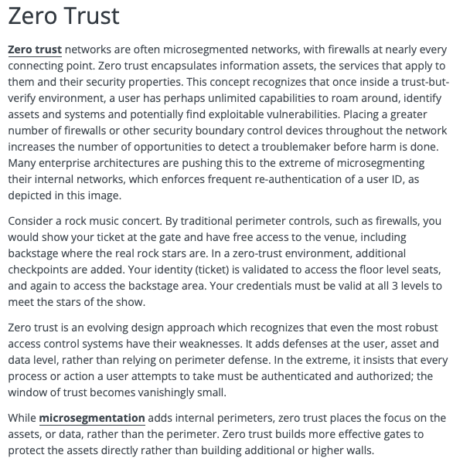

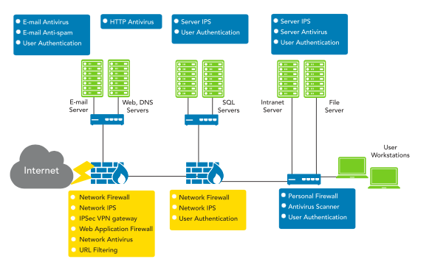

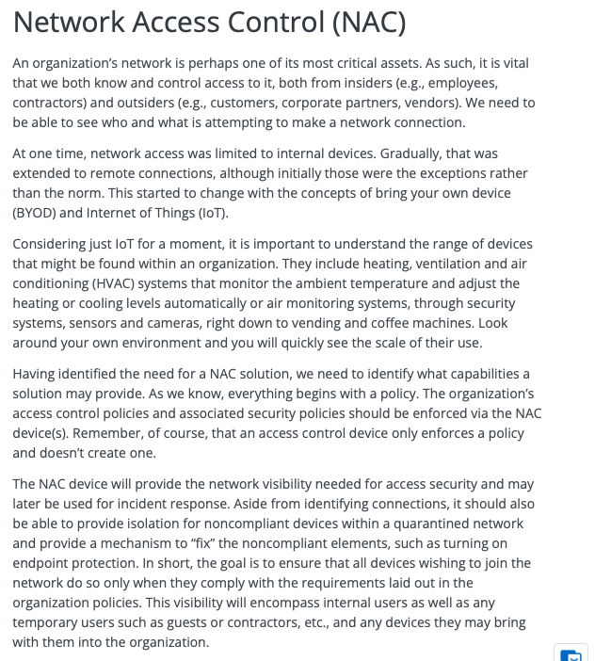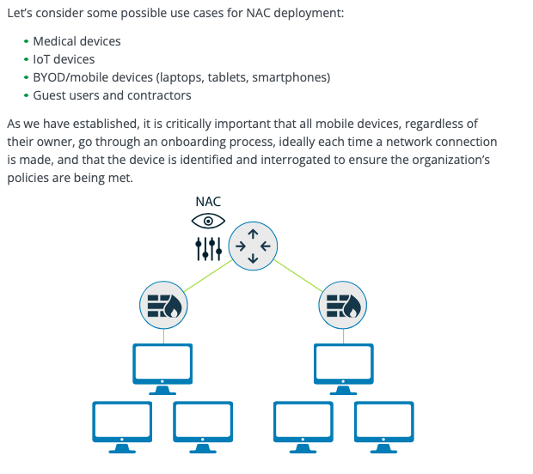

NAC Deeper Dive

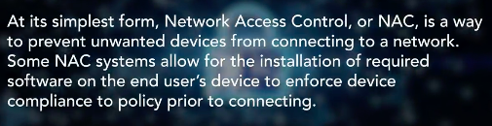

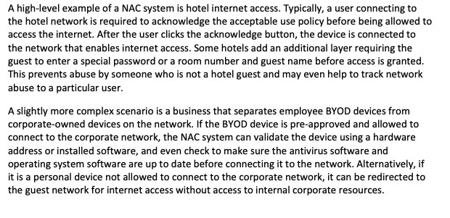

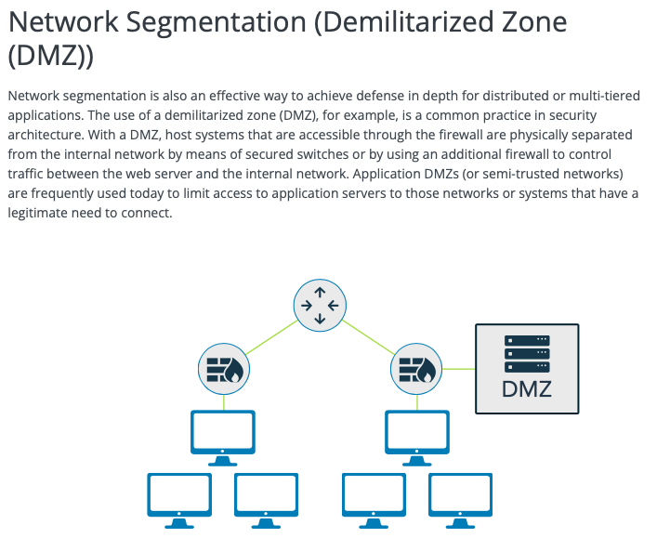

DMZ Deeper Dive

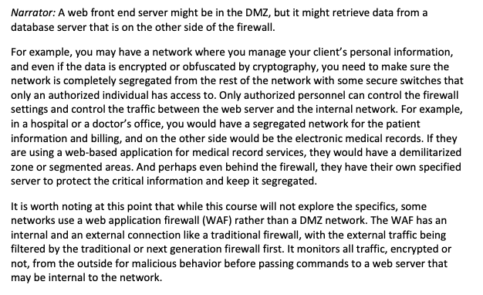

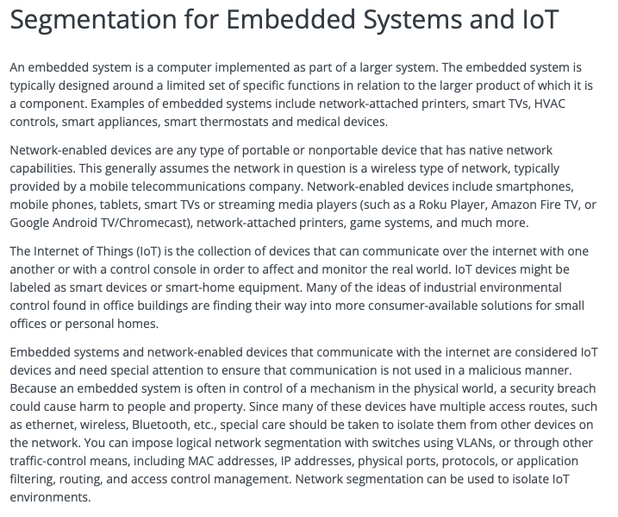

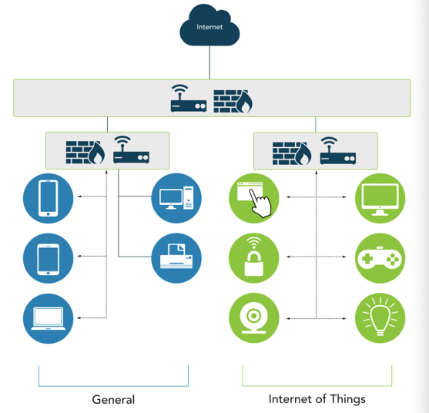

Segmentation for Embedded Systems and IoT Deeper Dive

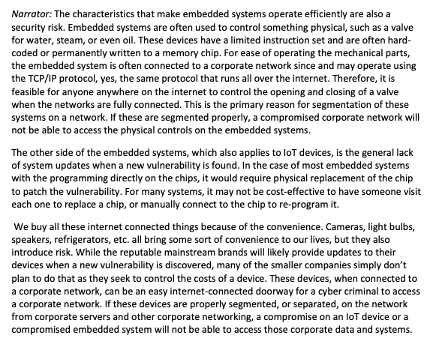

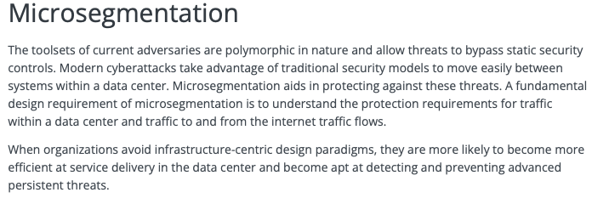

Microsegmentation Deeper Dive

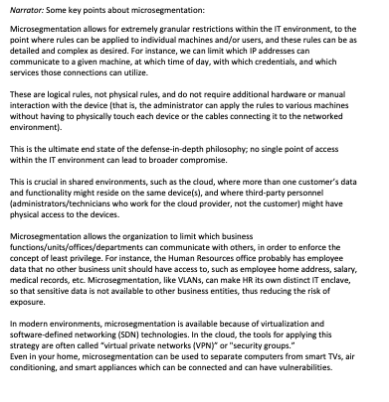

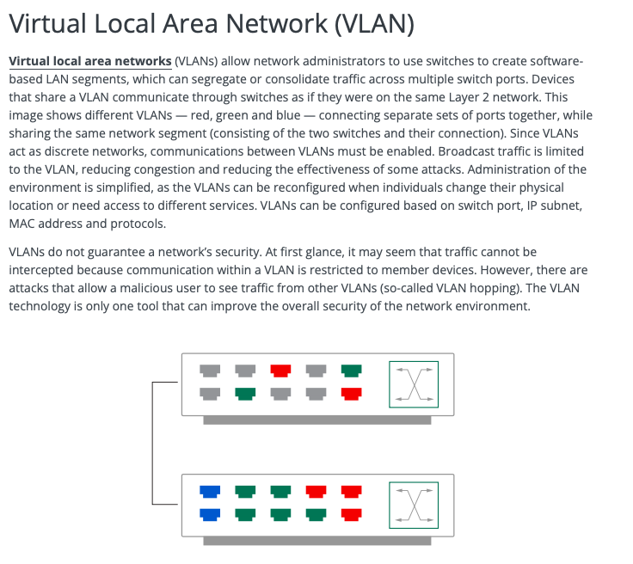

VLAN Segmentation

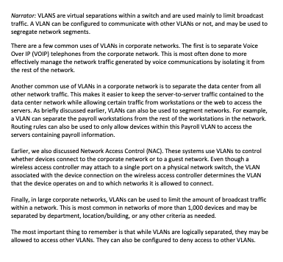

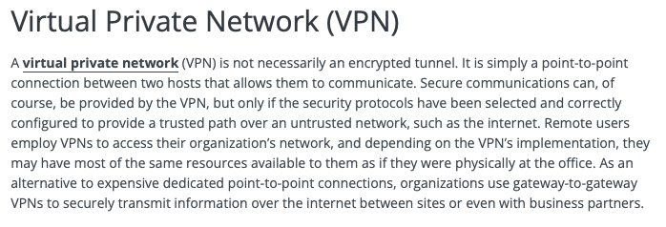

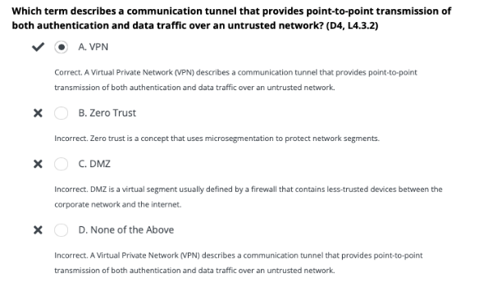

Chapter 4 Terms

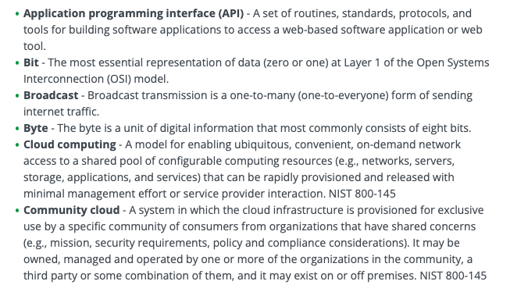

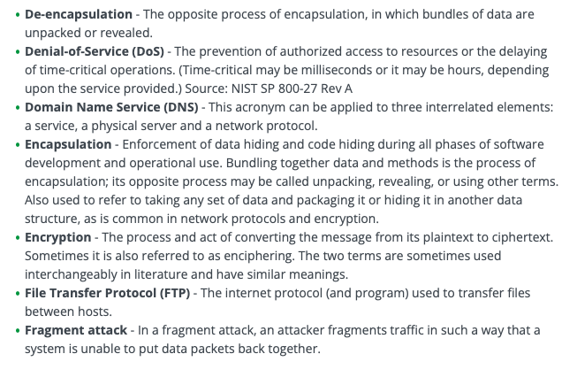

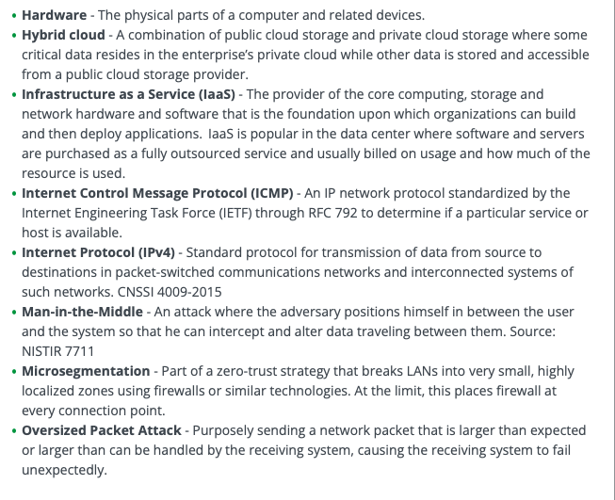

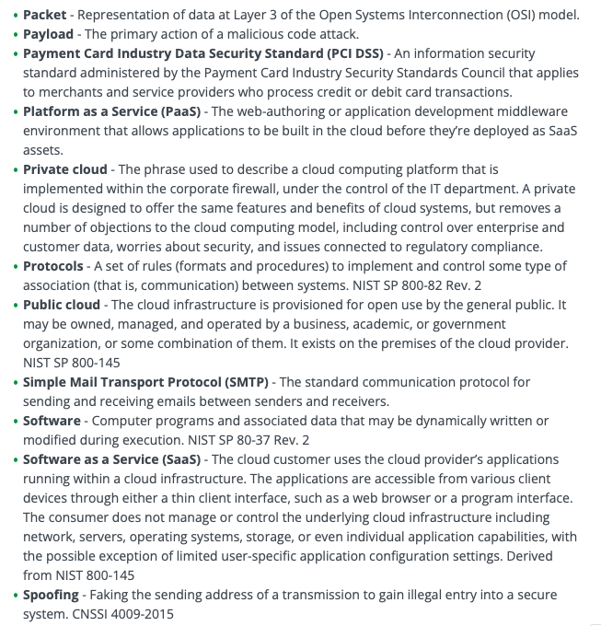

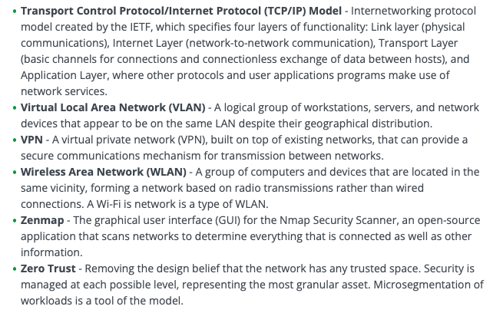

**END OF CHAPTER 4**

**Chapter 5: Security Operations**

5.1- Understand Data Security

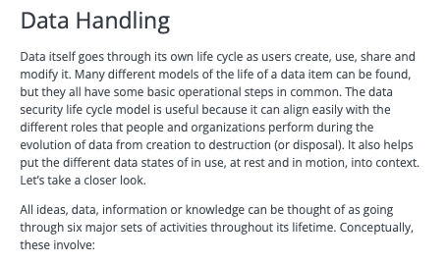

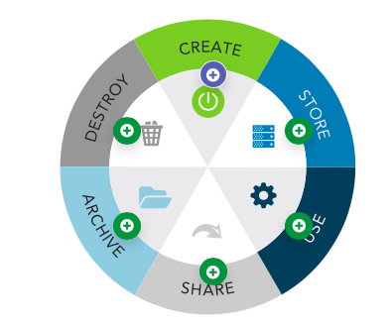

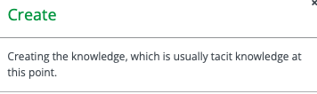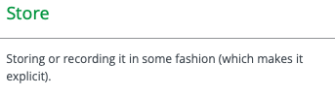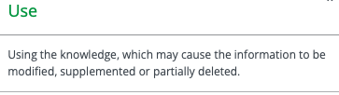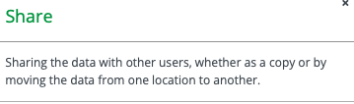

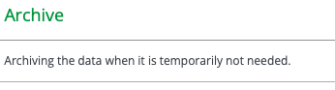

Data Handling Deeper Dive

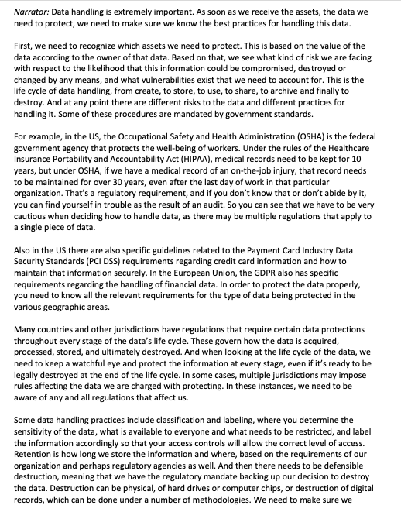

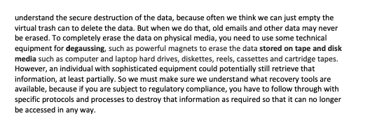

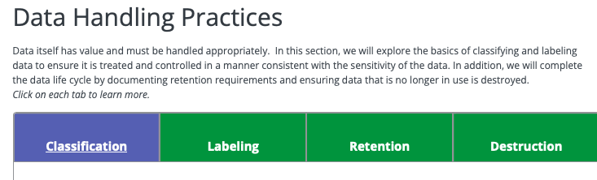

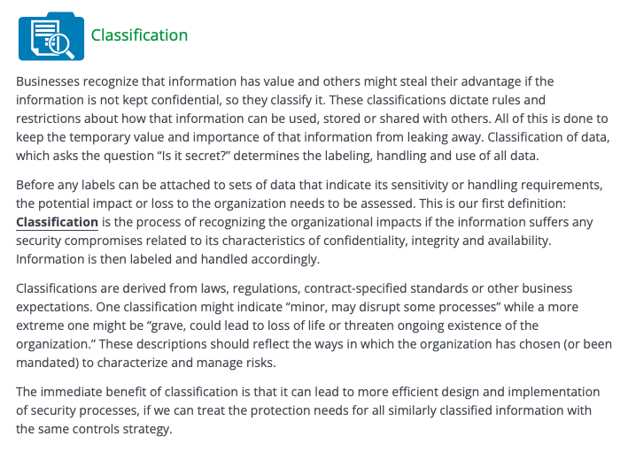

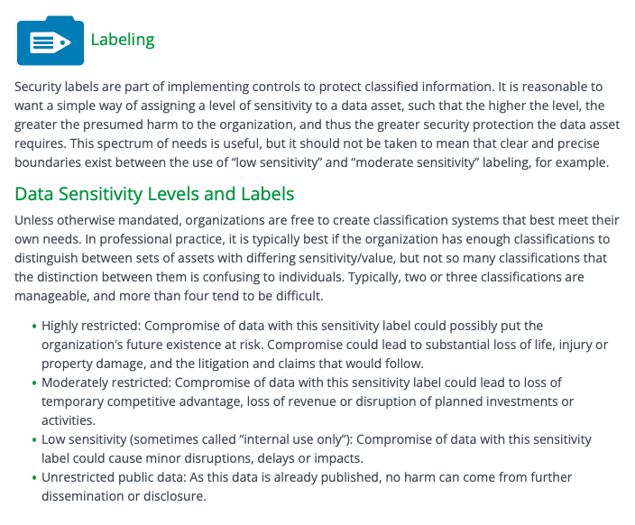

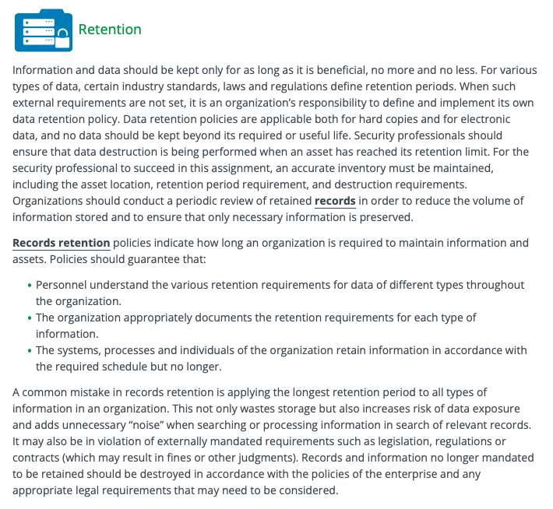

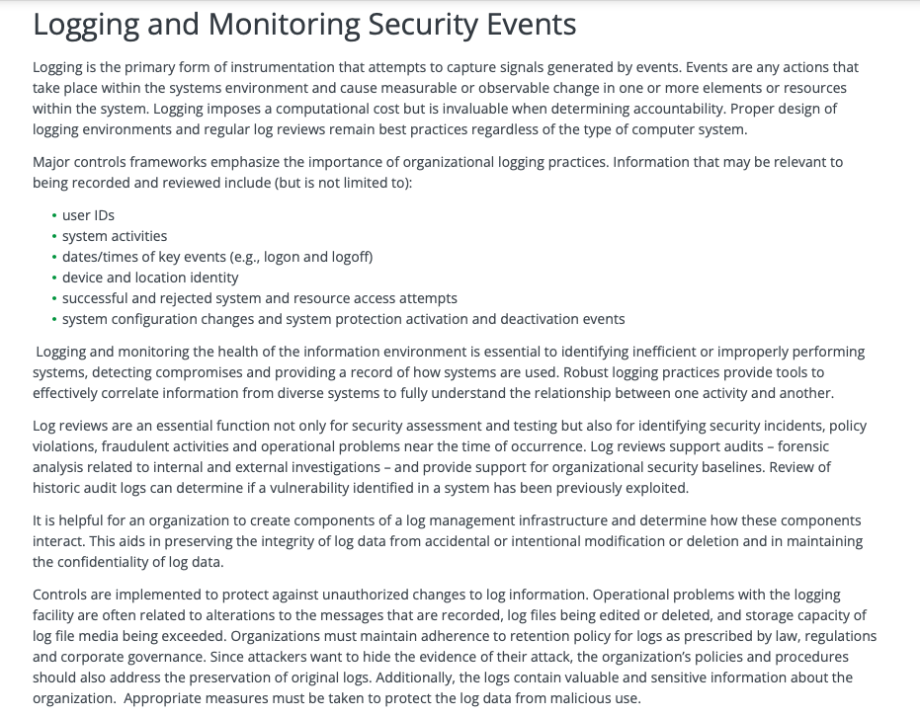

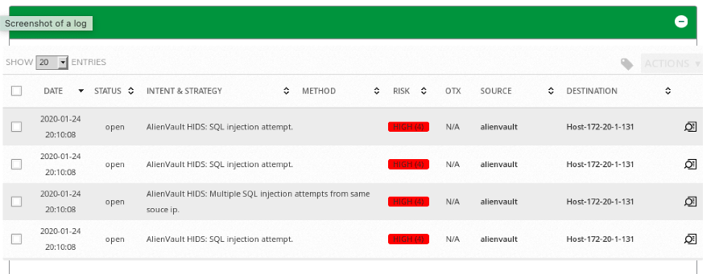

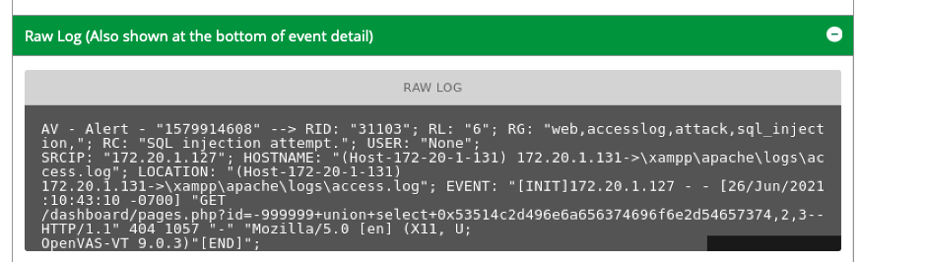

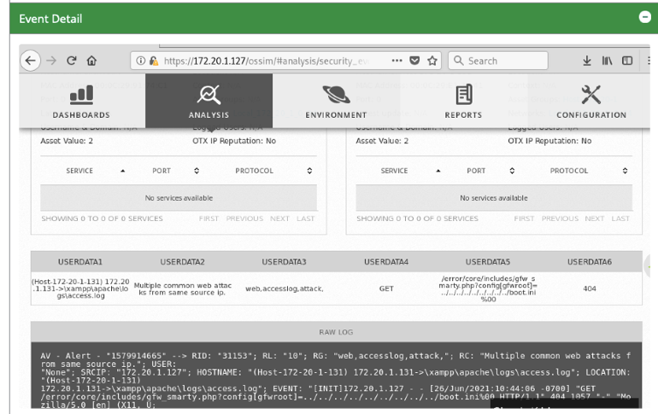

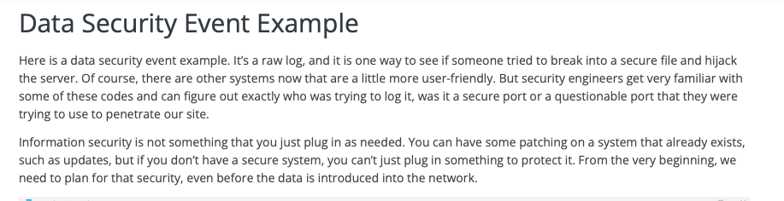

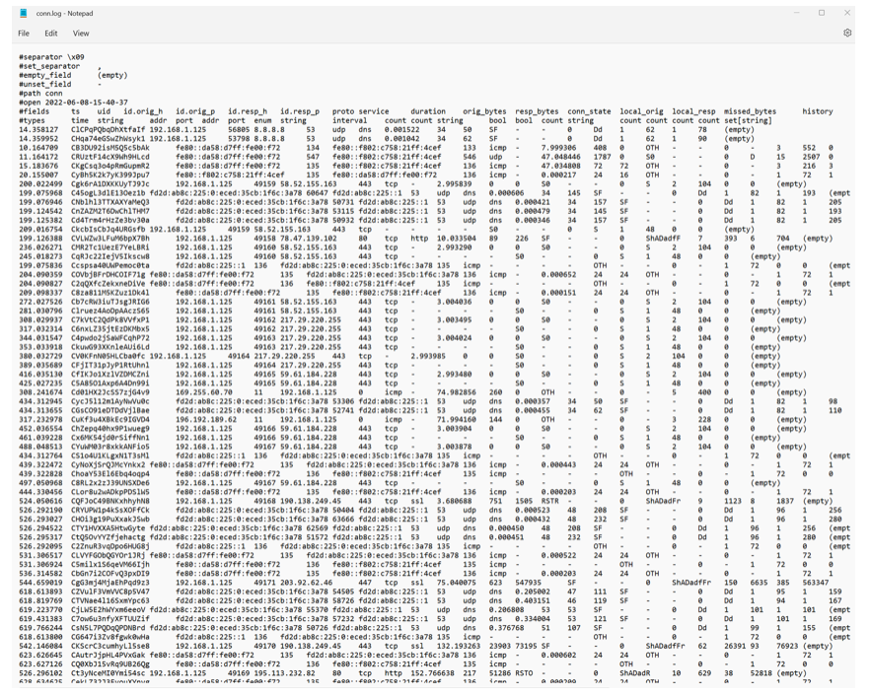

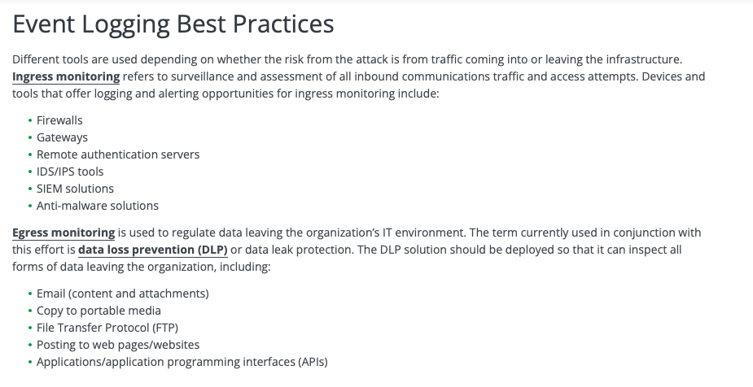

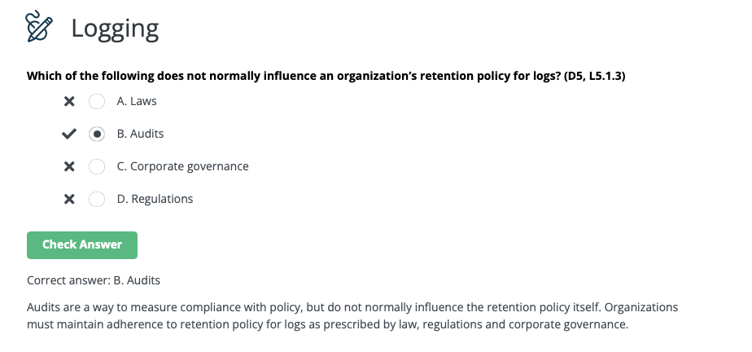

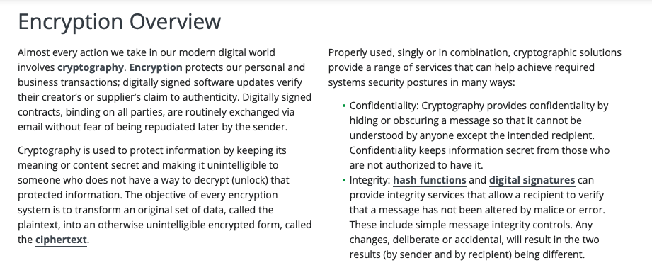

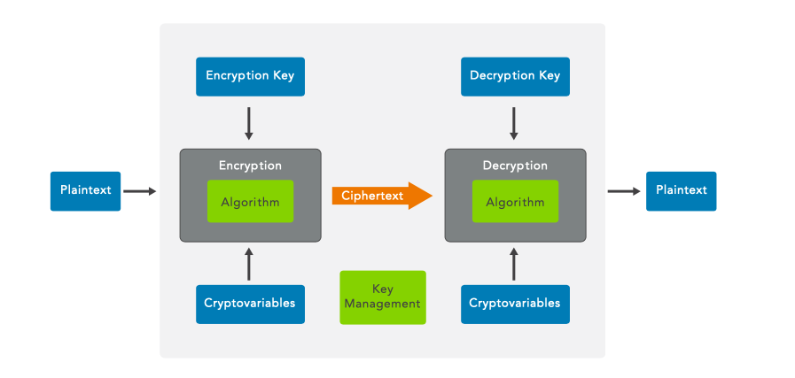

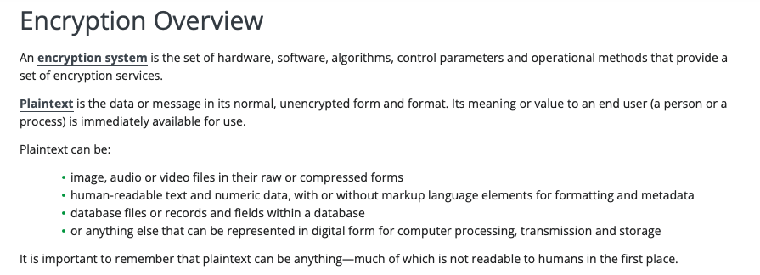

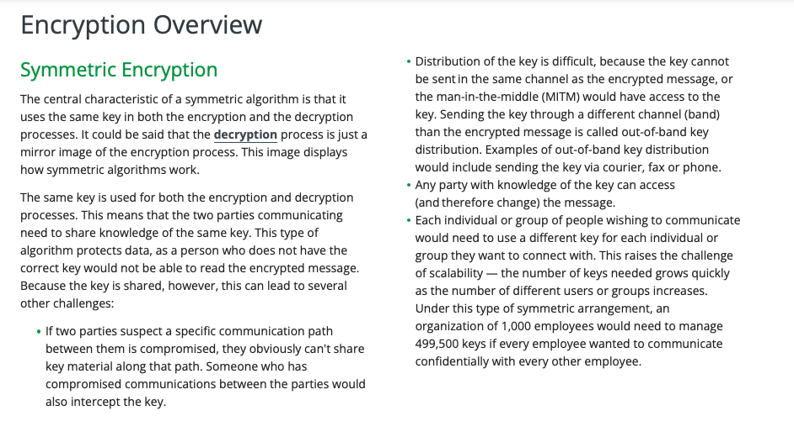

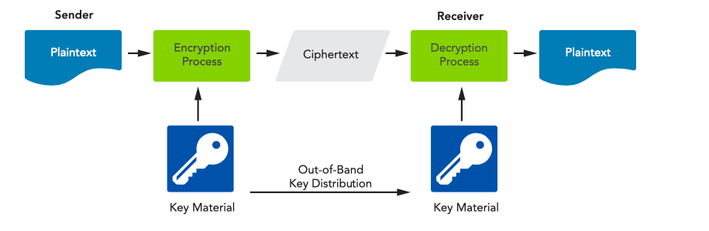

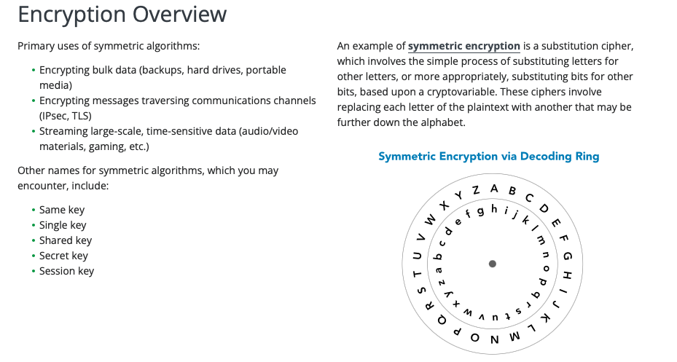

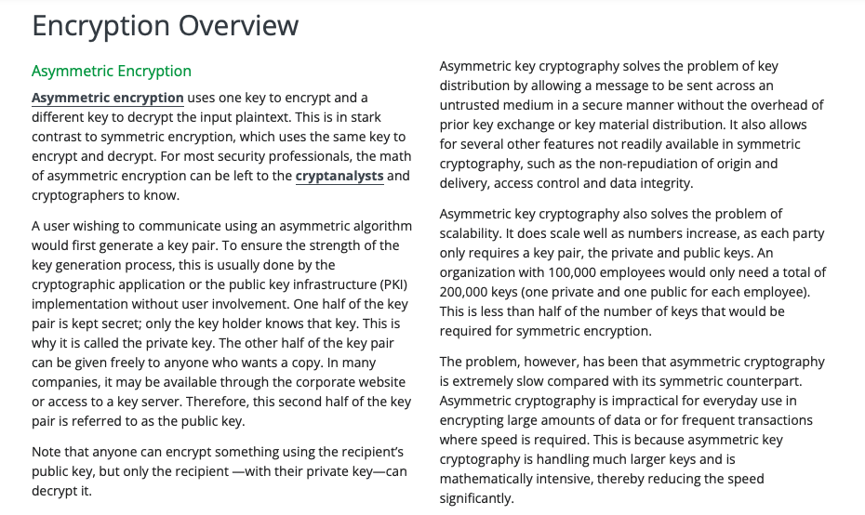

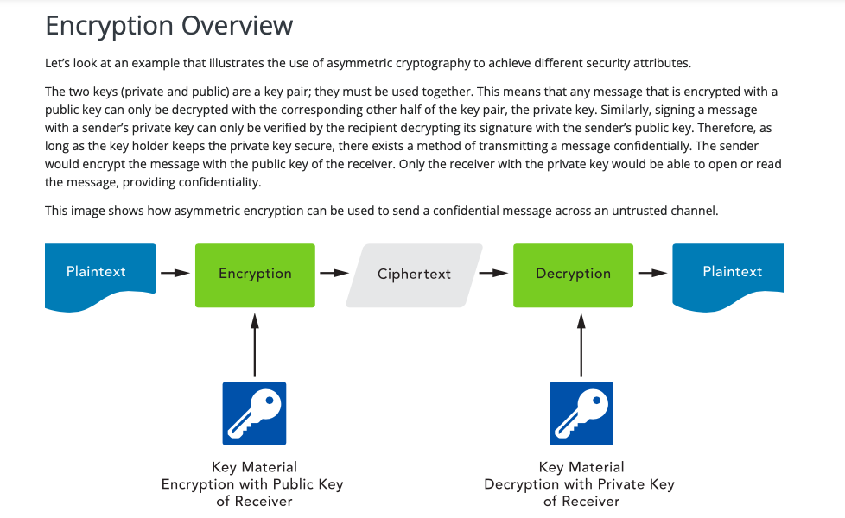

Encryption Deeper Dive

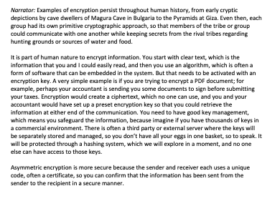

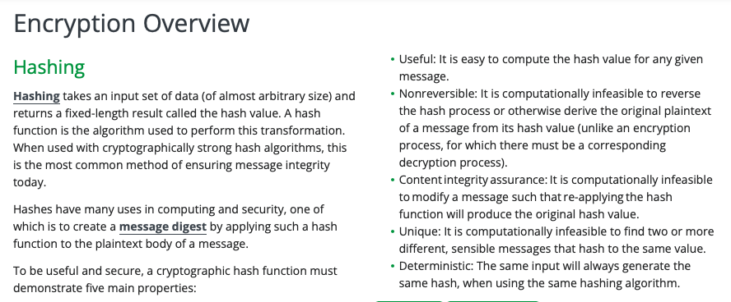

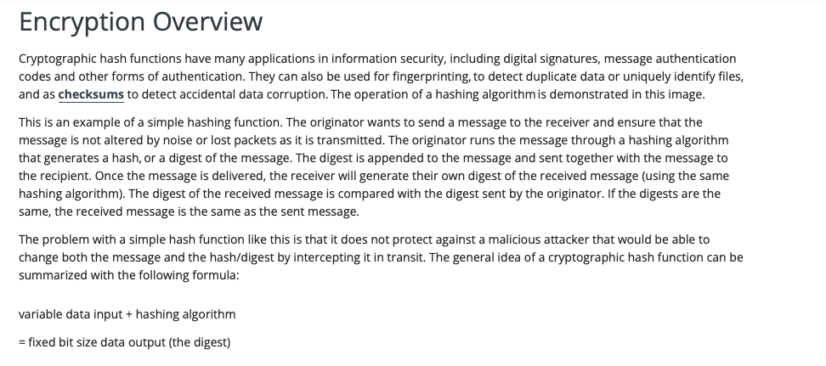

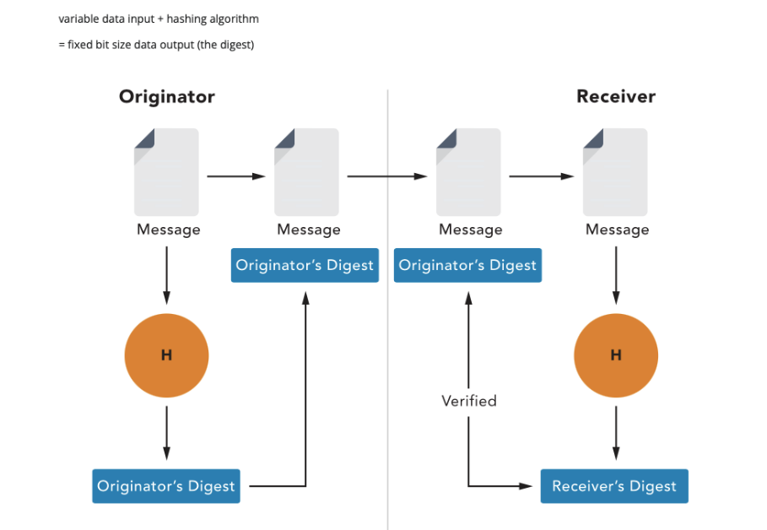

How Passwords Work

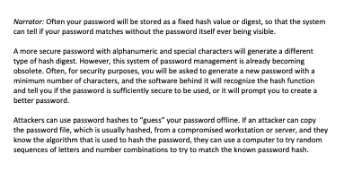

5.2-Understand System Hardening

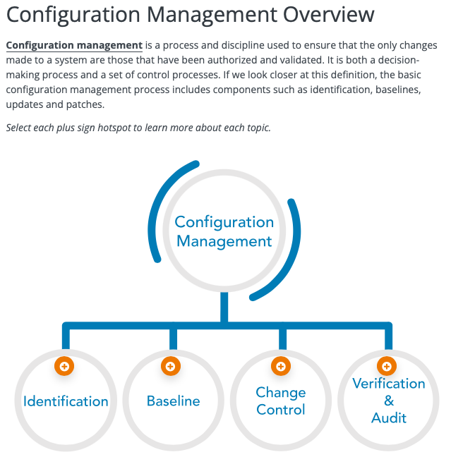

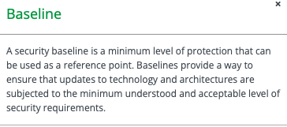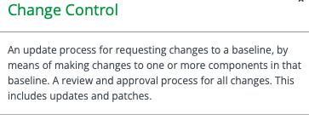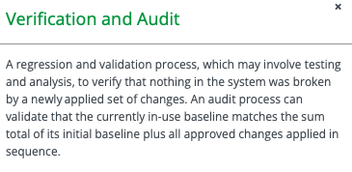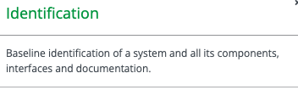

Risks of Change

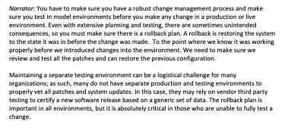

5.3-Understand Best Practice Security Policies

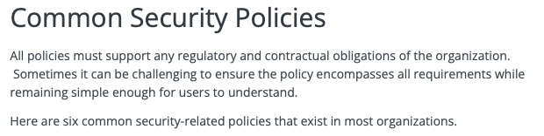

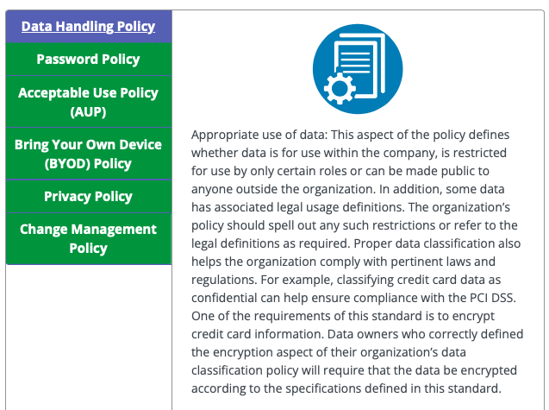

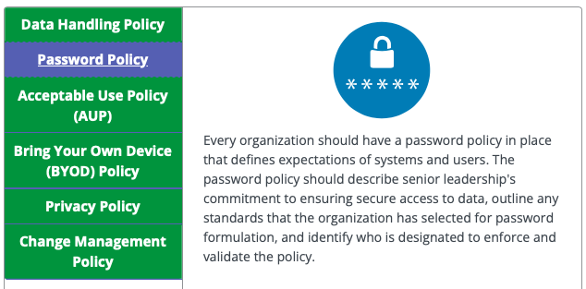

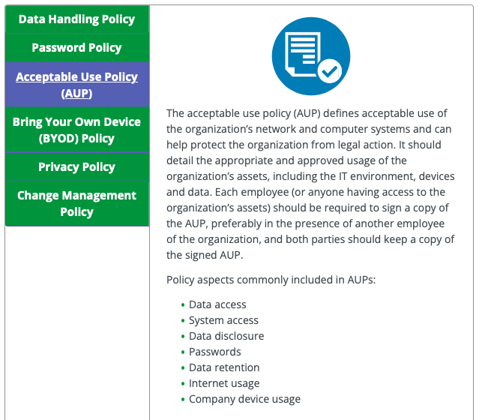

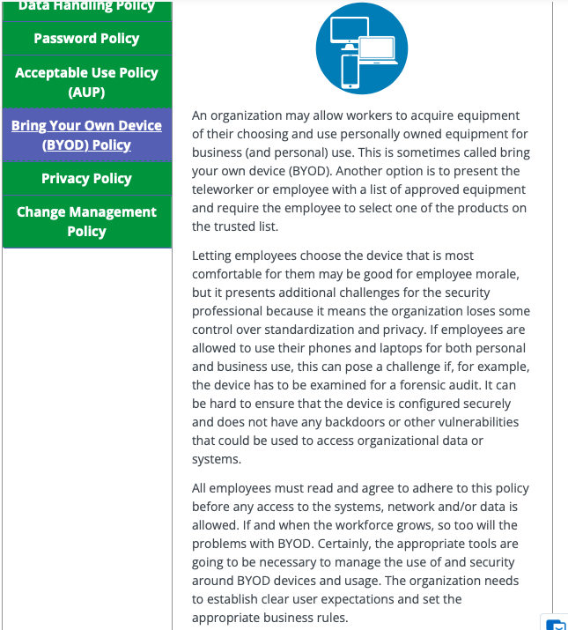

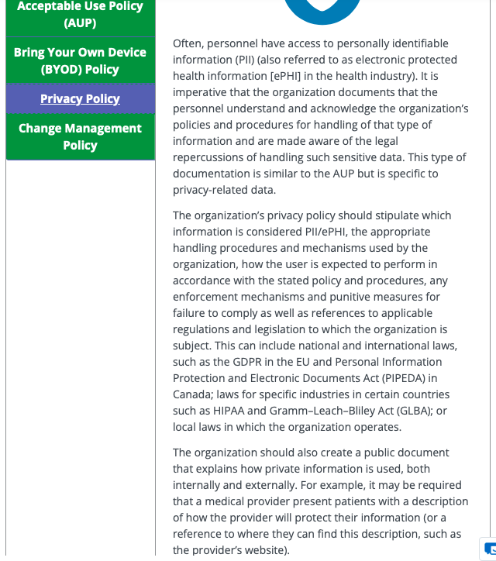

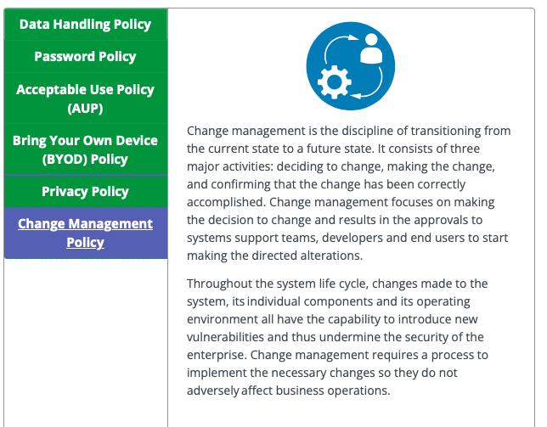

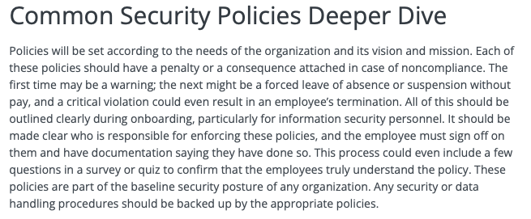

Keith Writes a Password Policy

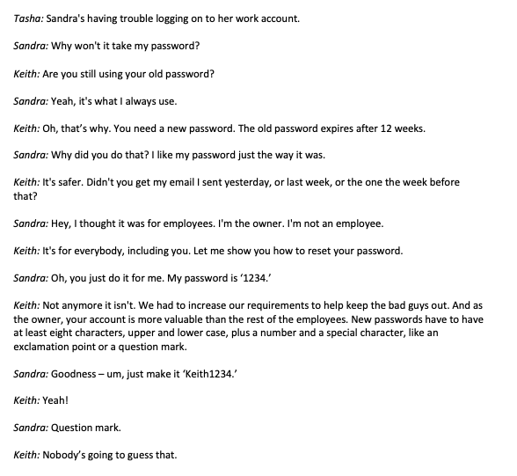

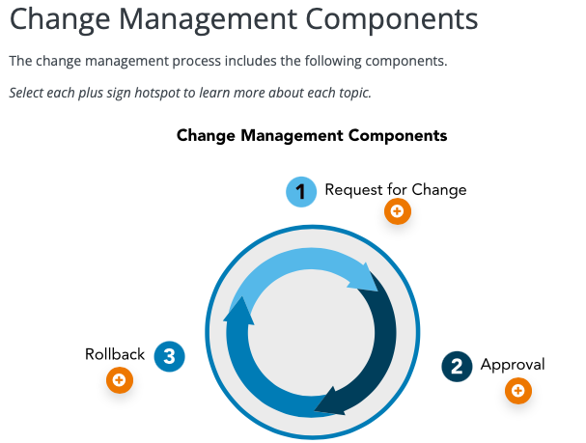

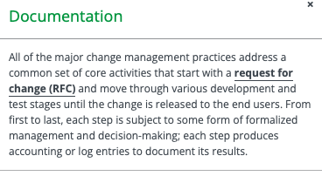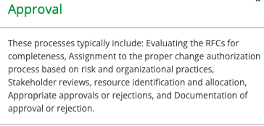

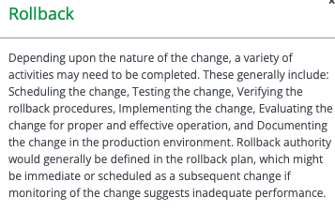

Change Management Components in the Workplace

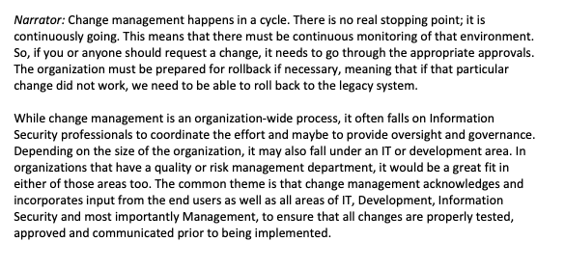

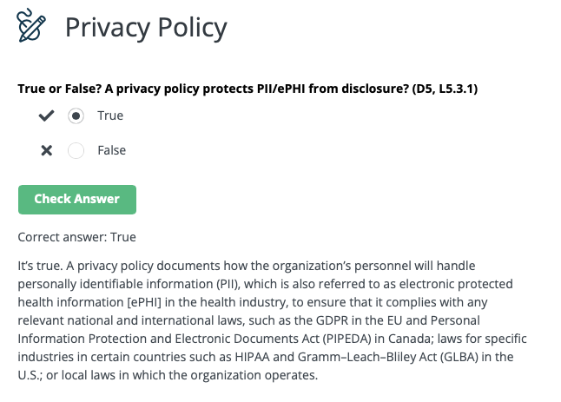

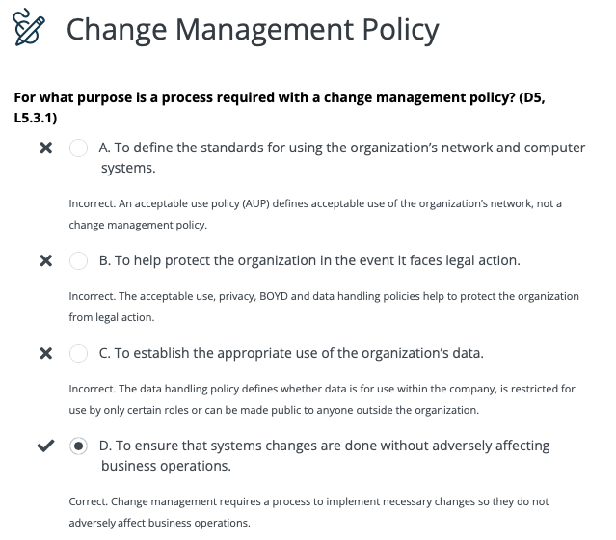

Supporting Security Policies and Procedures

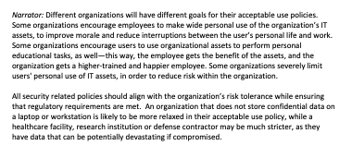

5.4- Understand Security Awareness Training

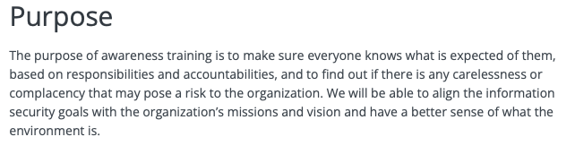

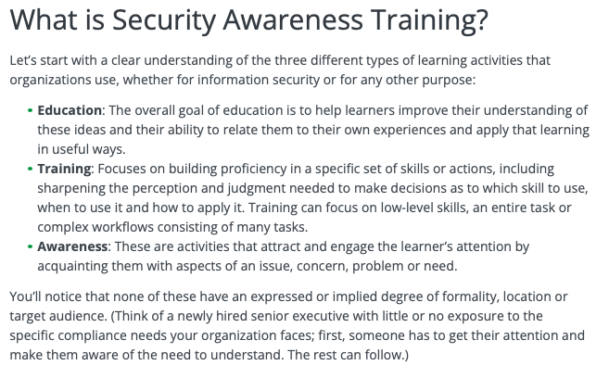

Importance of Secuirty Training

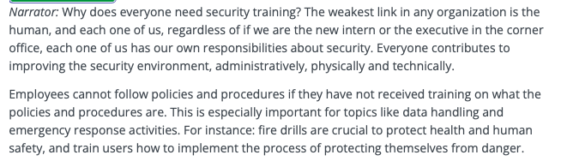

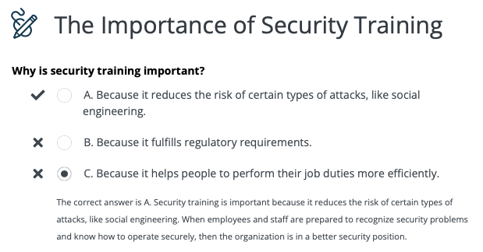

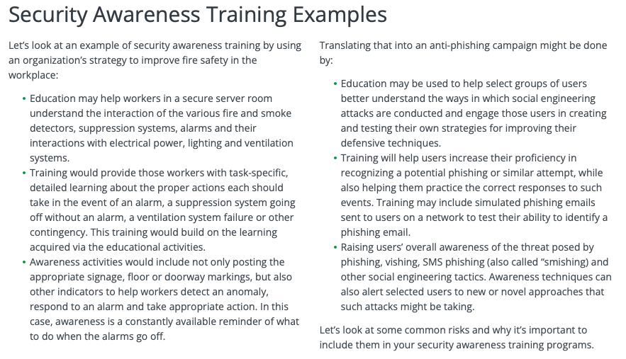

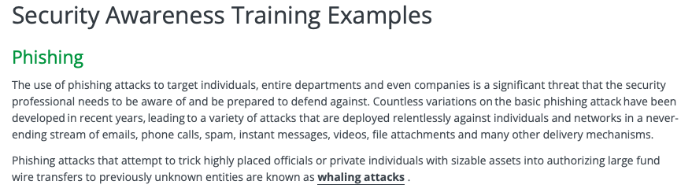

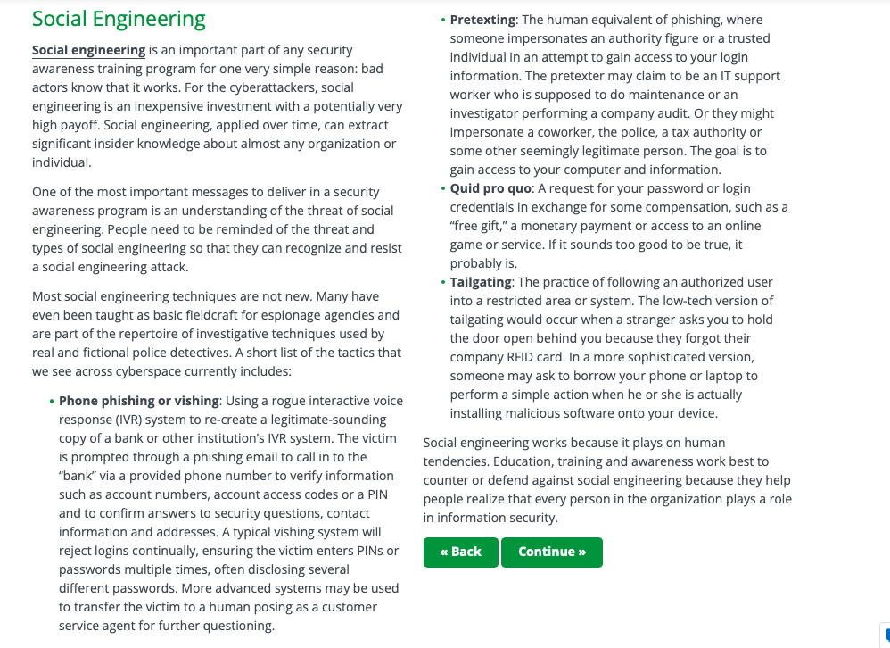

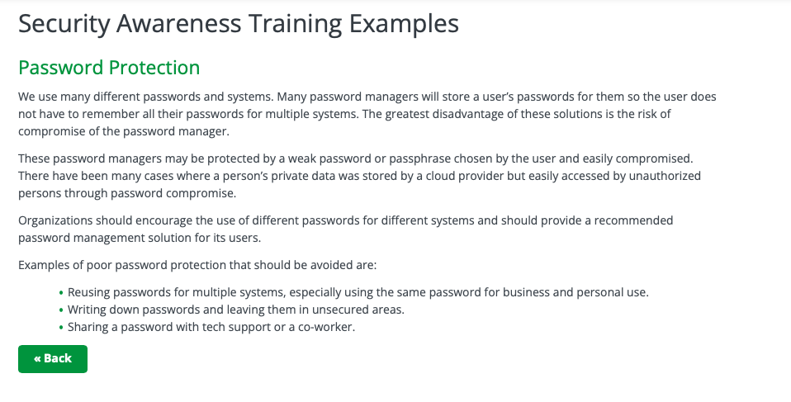

Password Advice and Examples

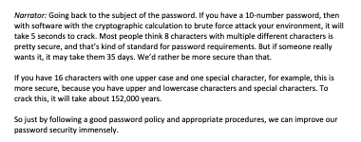

Best Practices of Security Awareness Training

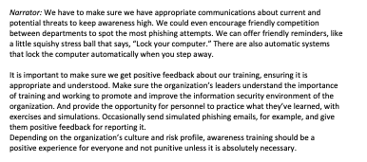

Chapter 5 Terms

